**Optional** – needed to avoid null checks everytime

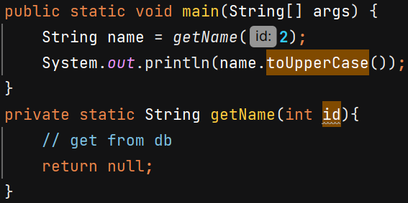 O/P 🡪 NullPointerException

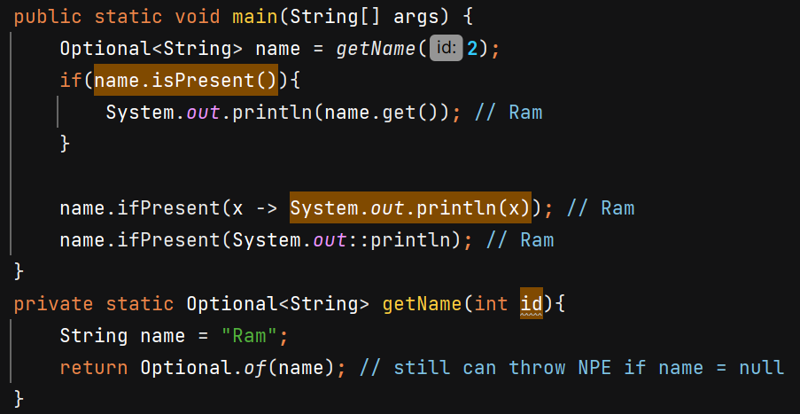

isPresent() checks if value is not null

ifPresent() takes a consumer and perform the task if value is not null.

Better to use - 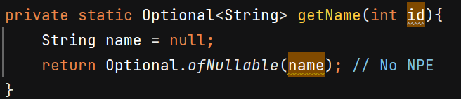

ofNullable 🡺 Returns an Optional describing the given value, if non-null, otherwise returns an empty Optional.

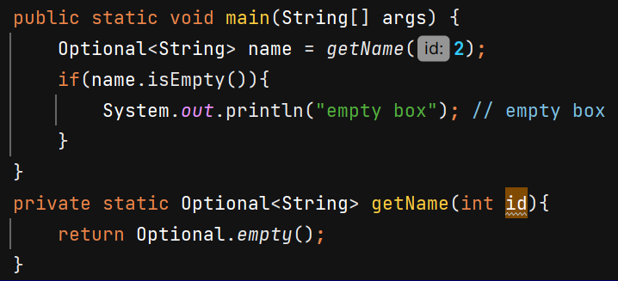

If value is null or empty we can get error so always check presence first –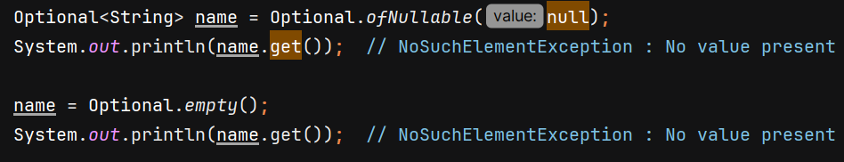

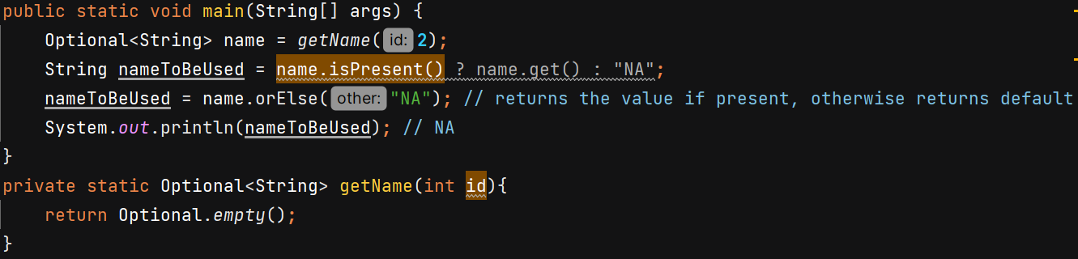

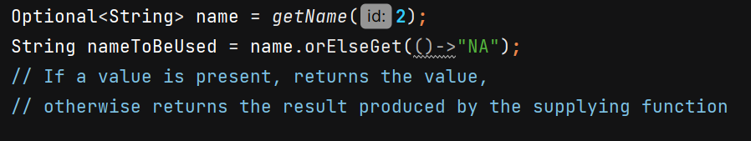

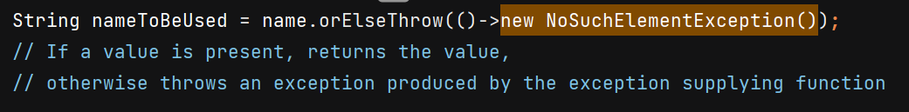

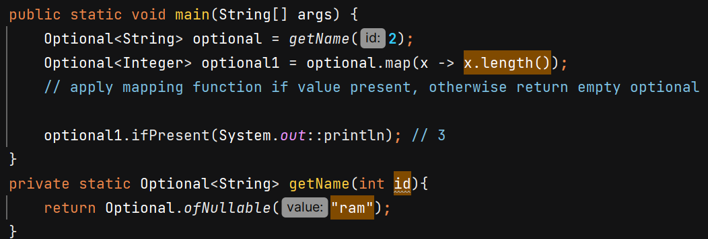

**Method References** 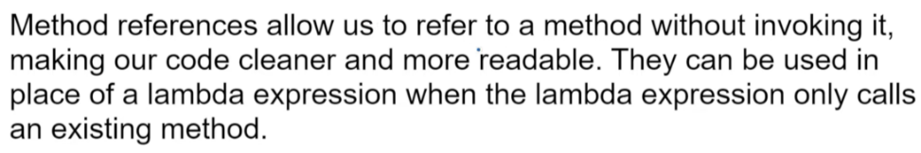

1. Reference to a Static method –

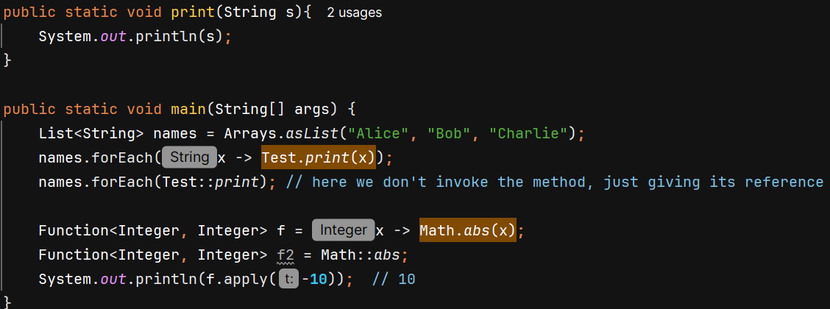

2. Reference to an Instance Method of a Specific Object -

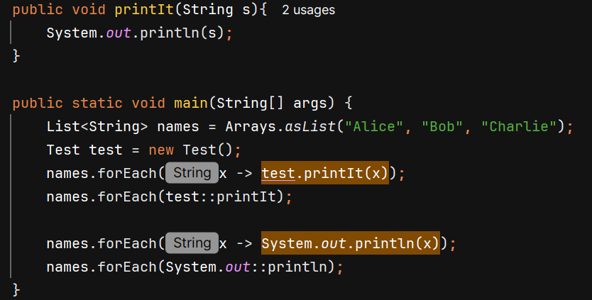

3. Reference to an Instance Method of a Class -

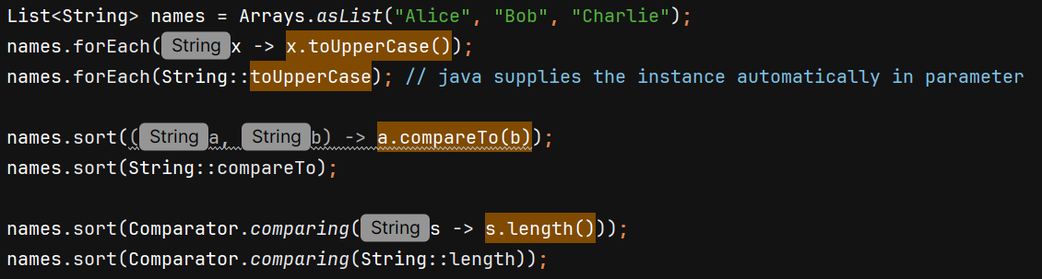

**Constructor Reference**

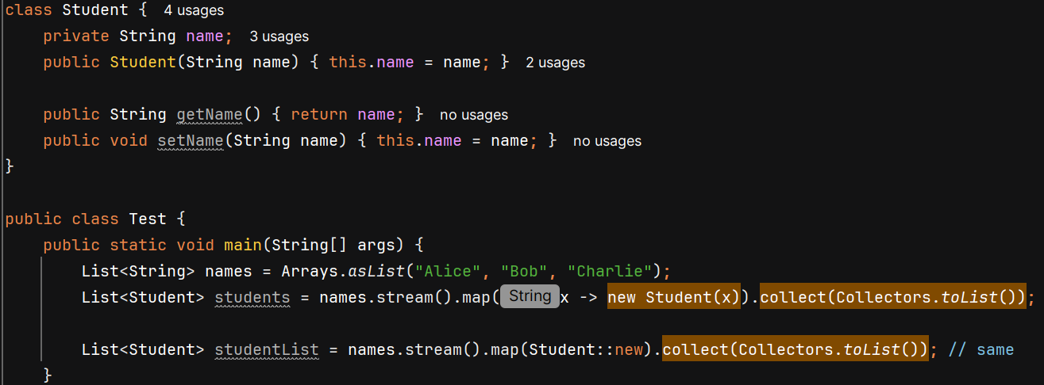

**Streams**

* Java 8 -> minimal code, functional programming (treating function as variable)
* new features -> lambda expression, Streams, Date & Time API

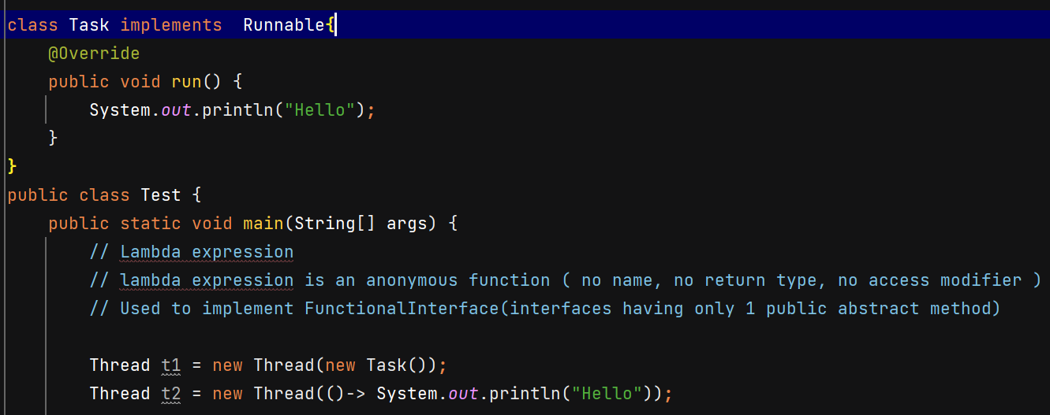

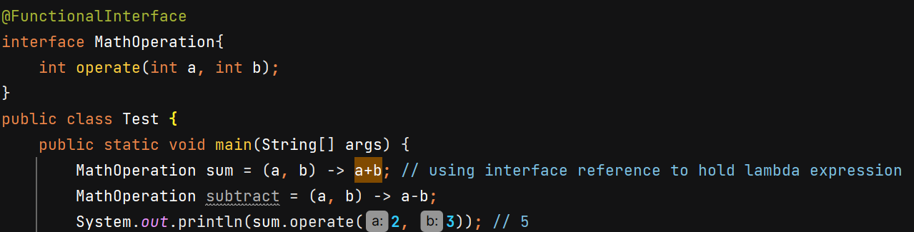

Predicate 🡪 functional interface (boolean valued function)

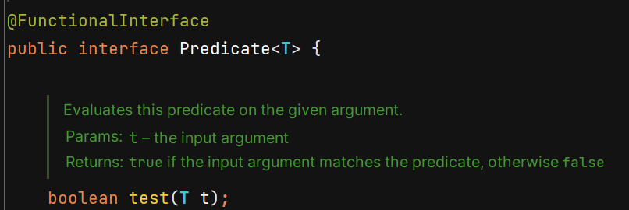

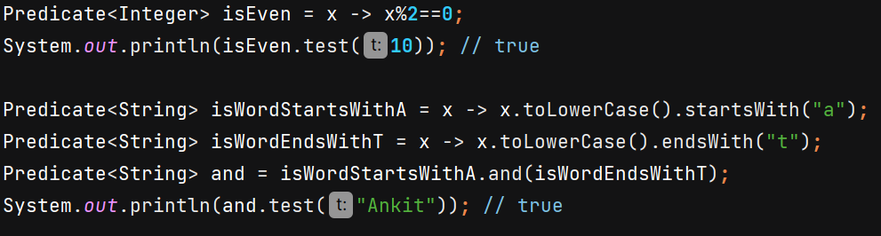we can add(), or(), negate() etc with Predicate

Function 🡪 work for you

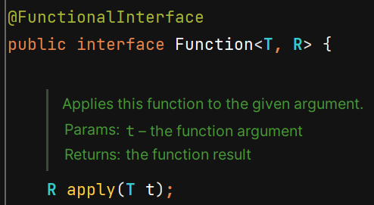

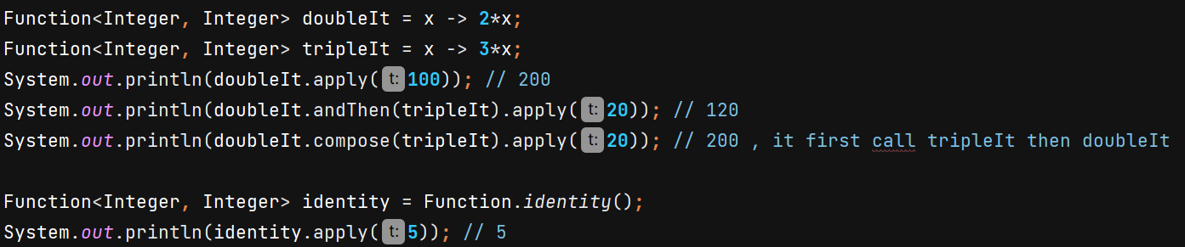

Consumer 🡪 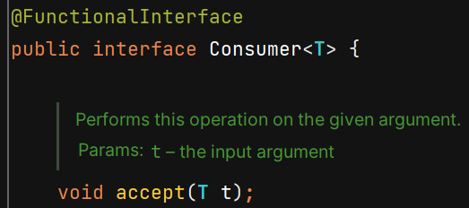

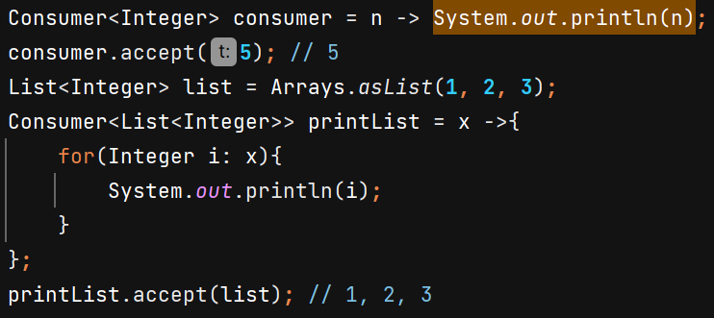 andThen() is available in it.

Supplier 🡪 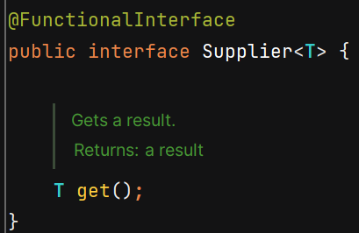



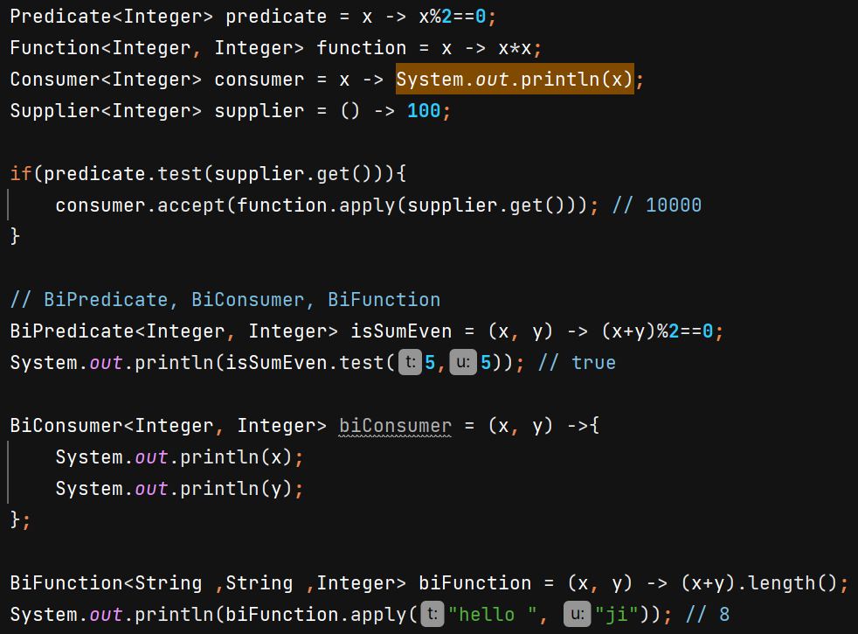

UnaryOperator 🡪 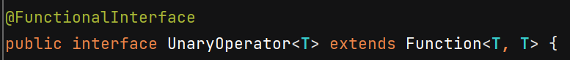

BinaryOperator 🡪 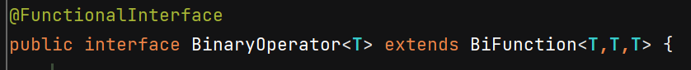

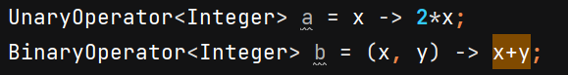

**Method Reference** 🡪 use method without invoking in place of lambda expression

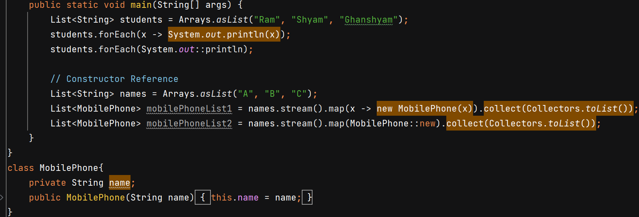

**Streams**

* process collections of data in a functional and declarative manner
* Simplify Data Processing
* Improve Readability and Maintainability
* Enable Easy Parallelism
* How to Use Streams?  
  Source**,** intermediate operations & terminal operation

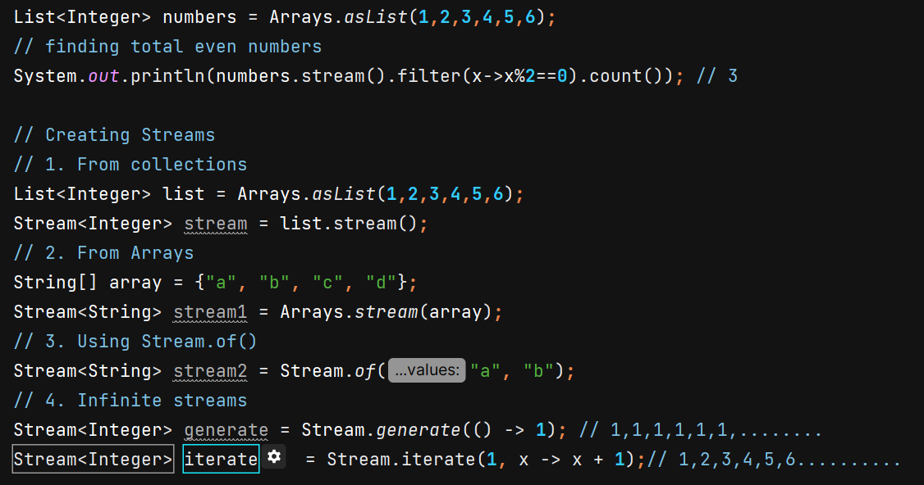

In Java, **streams are immutable** — once a stream is created, you **cannot add elements to it**.

Use of concat() and Stream.Builder –

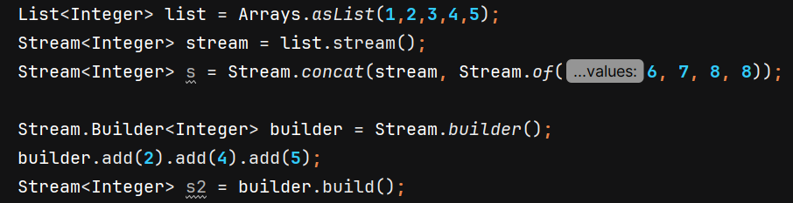

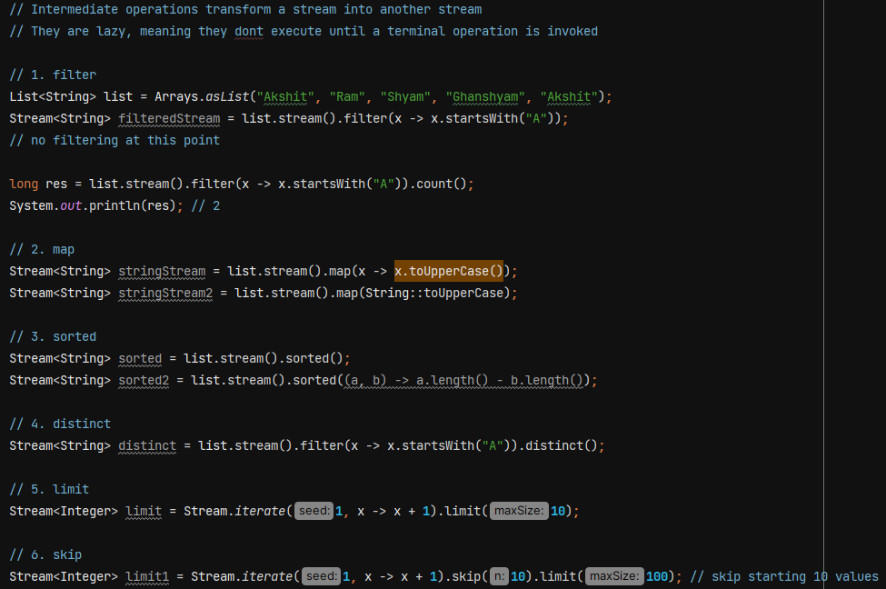

sorted() without comparator will sort in natural order.

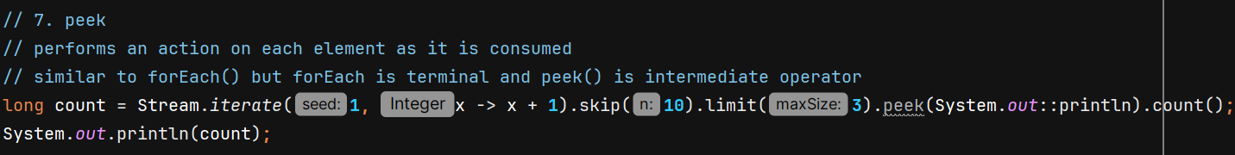

flatMap() is used when you have a **stream of collections (or arrays), and you want to "flatten" them into a single stream of their individual elements.**

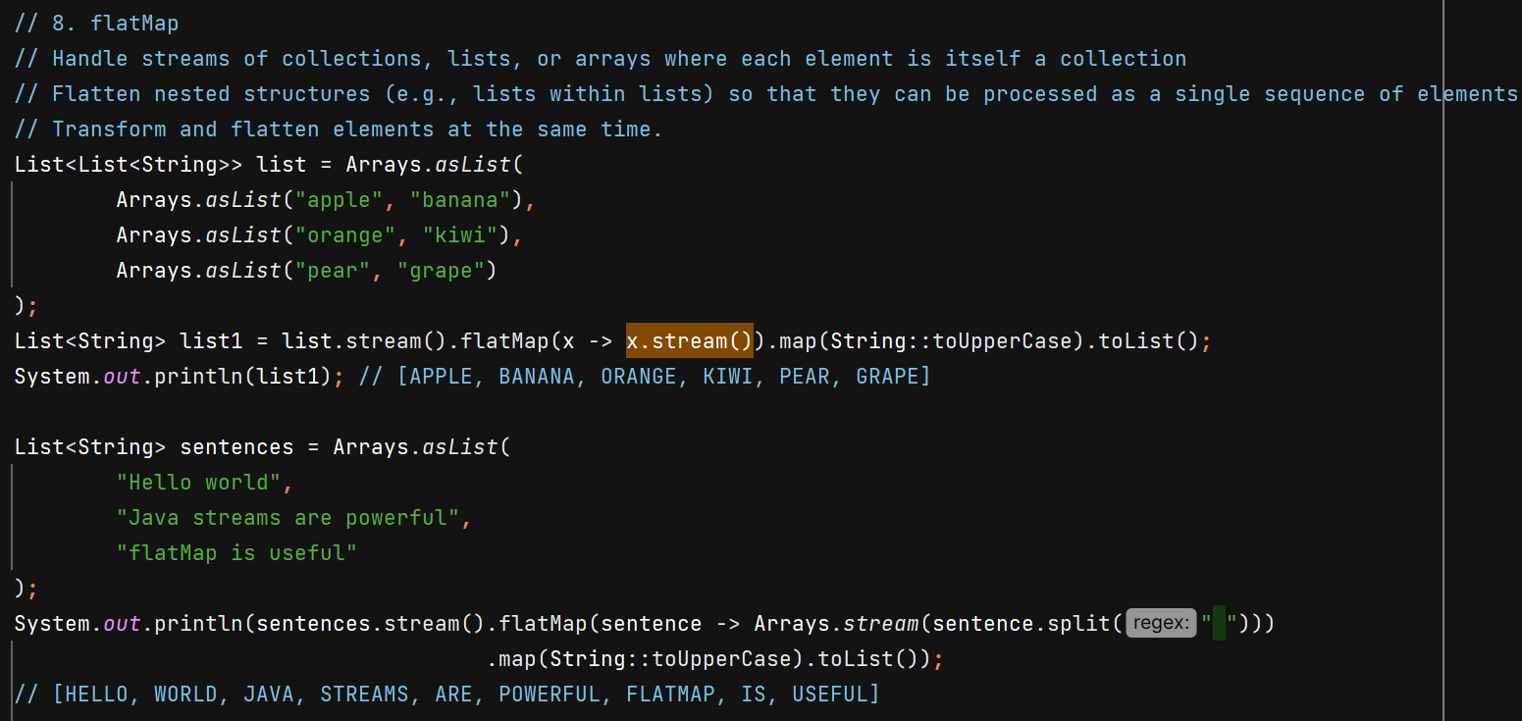

Terminal operators –

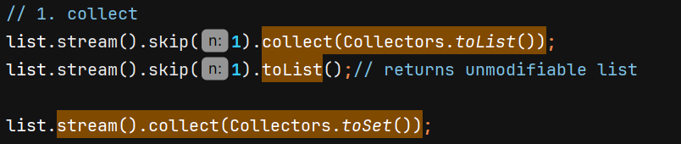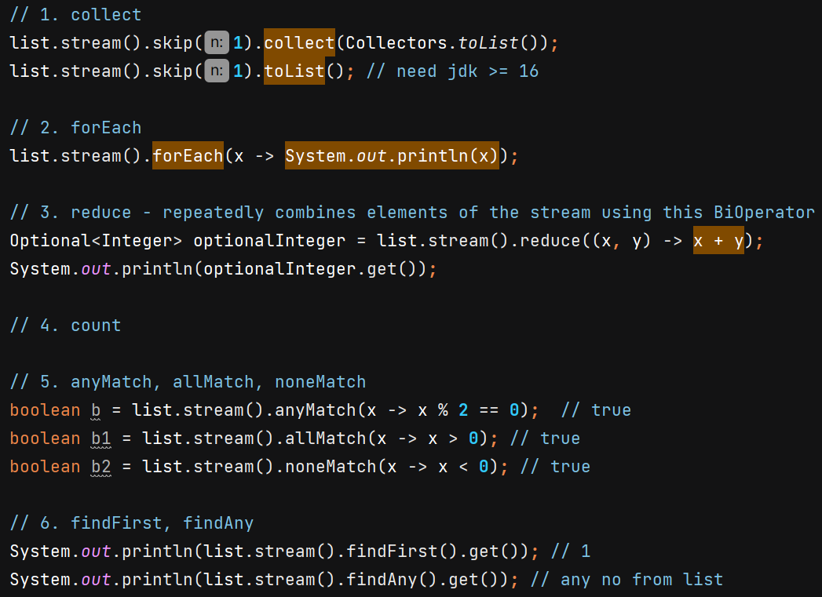

reduce() is getting used to accumulate

noneMatch() gives true when all the values don’t satisfy the given condition

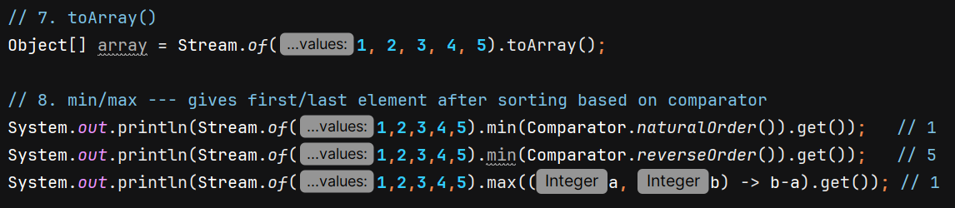

For Double we can’t simple do x-y because it will return a Double and comparator returns int

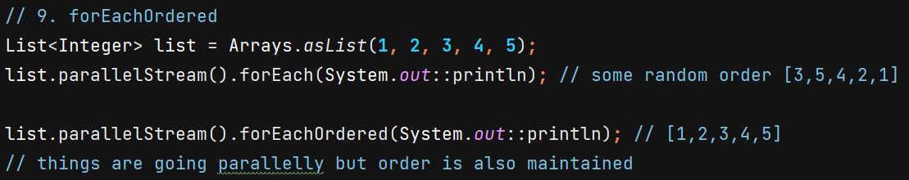

ParallelStream allows us to process elements of a stream in **parallel**, leveraging multiple CPU cores.

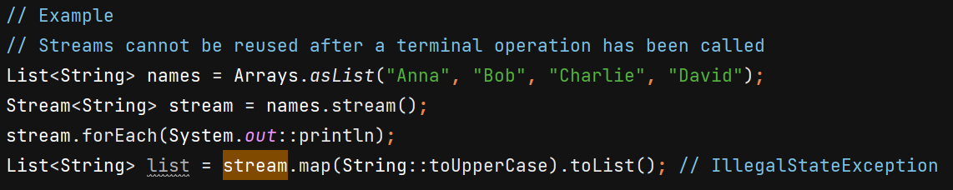

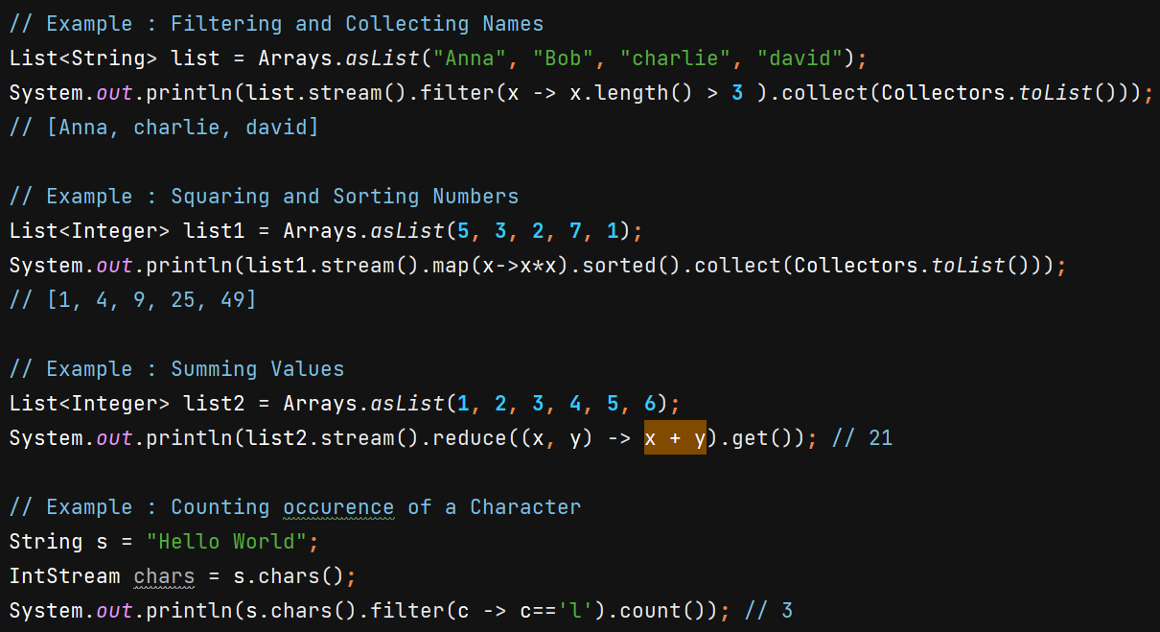s.chars() convert String in IntStream of ASCII codes

we can convert String in char Array using 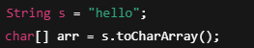 but Arrays.stream() don’t take char Array as parameter.

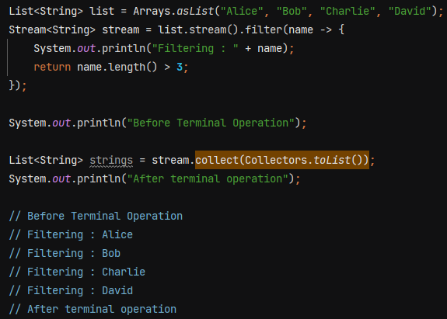

Parallel Streams –

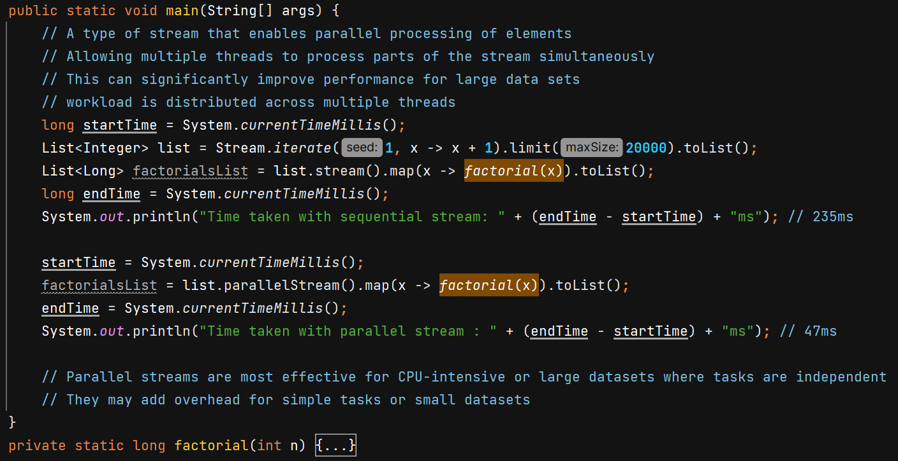

We can convert parallelStream to sequential –



parallelStream don’t work here as the task is not independent –

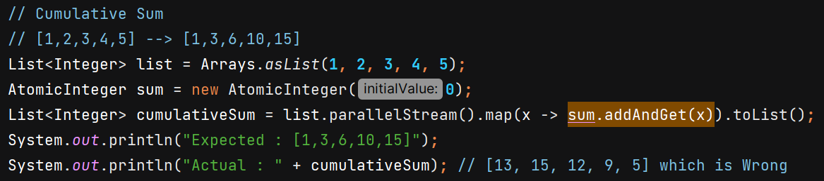

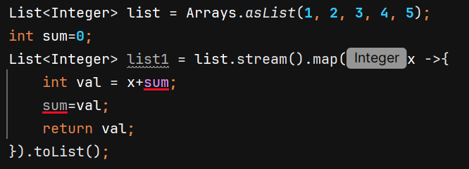

This code doesn’t work becoz **Variable used in lambda expression should be final or effectively final (The variable is assigned only once and never reassigned)** to avoid ambiguity and concurreny issues in parallelStream(), so we’ll use AtomicInteger for thread safety and it is effectively final.

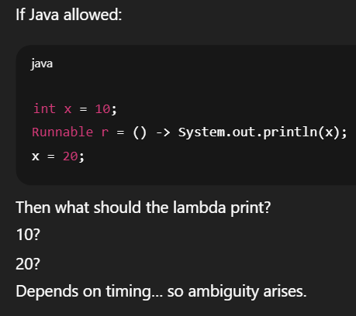

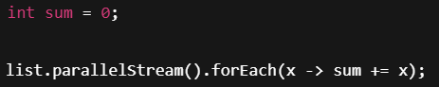 If this was allowed, then it can lead to Race condition as sum+=x is NOT atomic. It breaks into: read sum, add x, write sum

If multiple threads do this simultaneously:

* two threads may read the same old value
* both add their own x
* one write overwrites the other’s value

This leads to **lost updates**.

Example:

Thread A: sum = 5 → add 3 → write 8  
Thread B: sum = 5 → add 4 → write 9

Expected sum = 12  
Actual sum = 9 → **Incorrect result.**

**Collectors** – It is a utility class which provides a set of method to create a common collectors

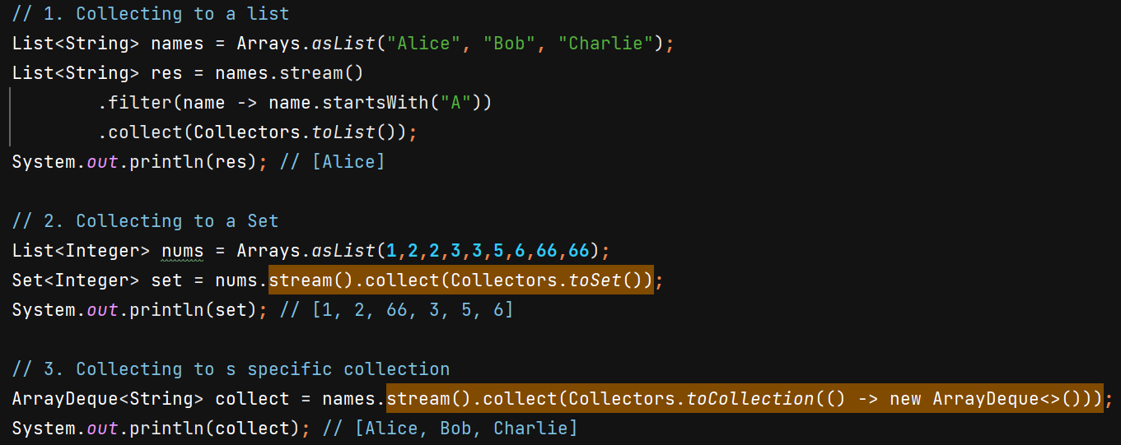

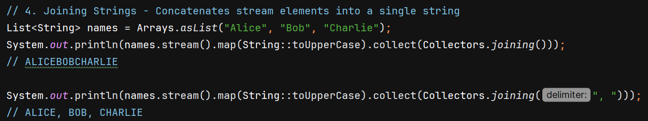

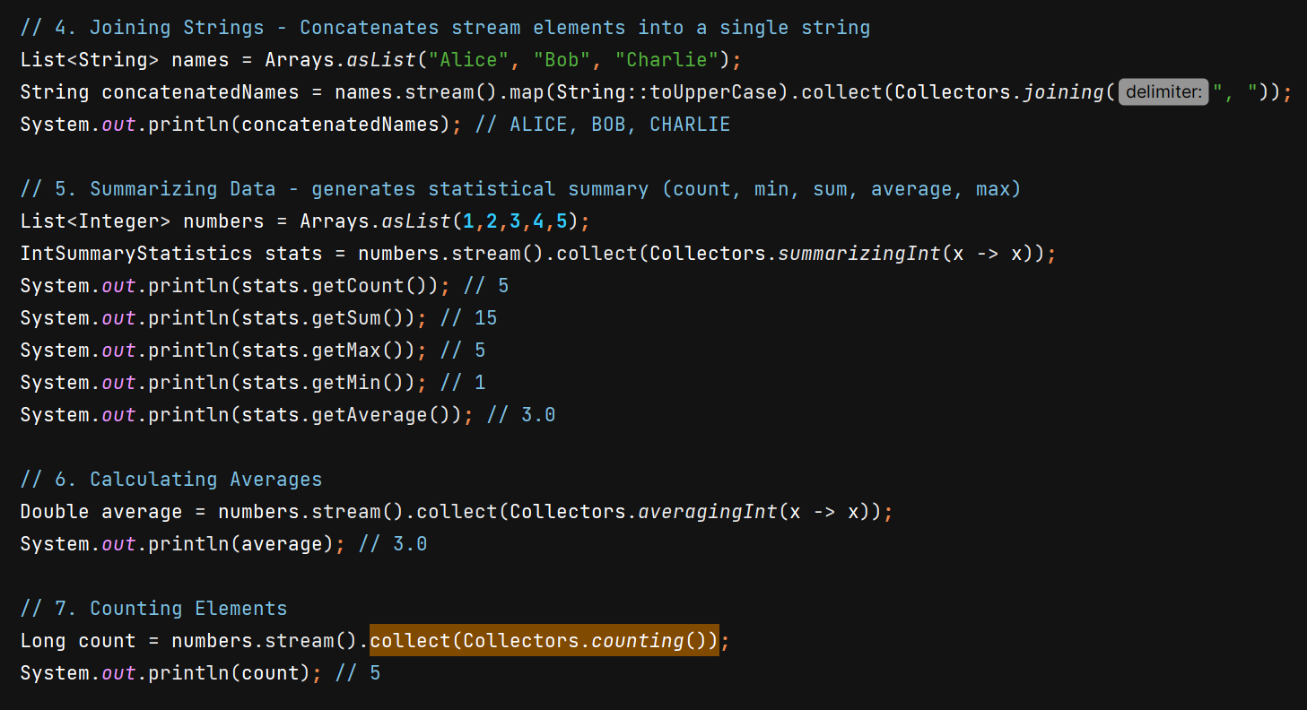

We also have summarizingDouble(), summarizingLong(), averagingDouble(), averagingLong(), summingInt(), summingDouble(), summingLong().

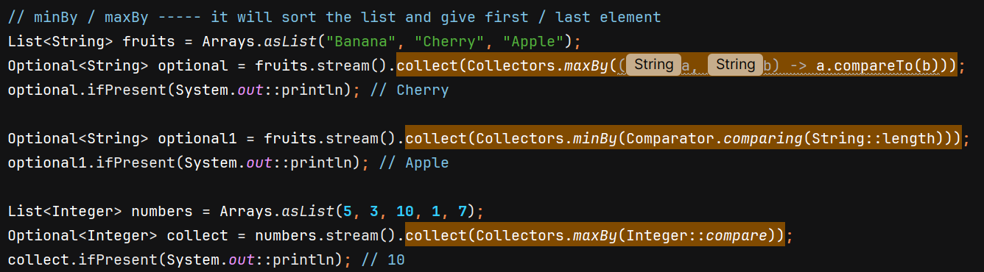

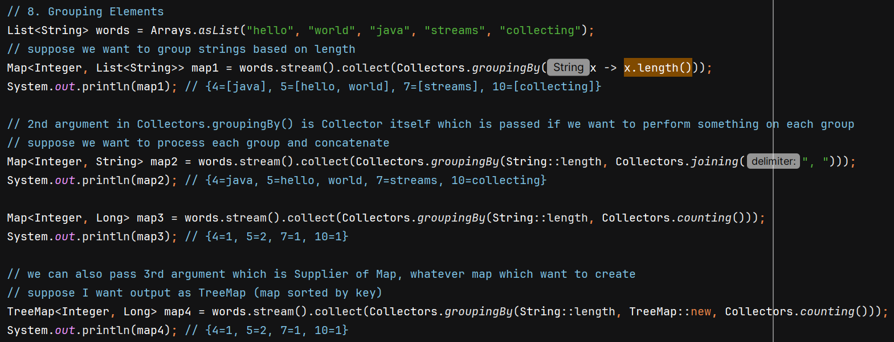

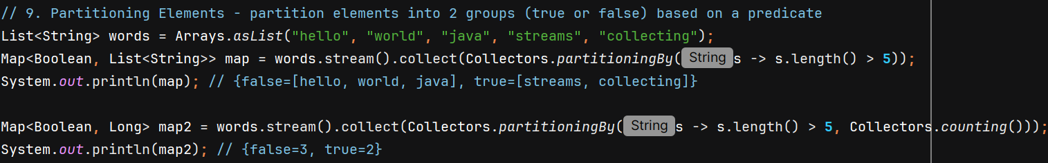

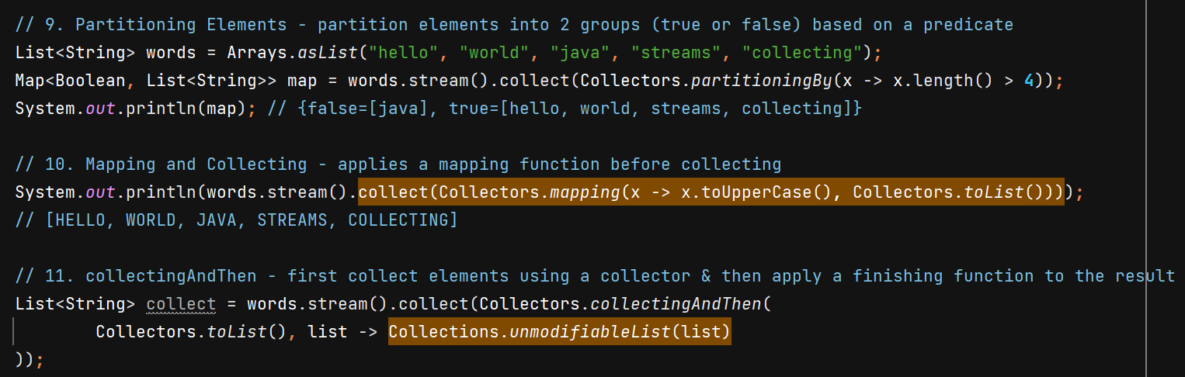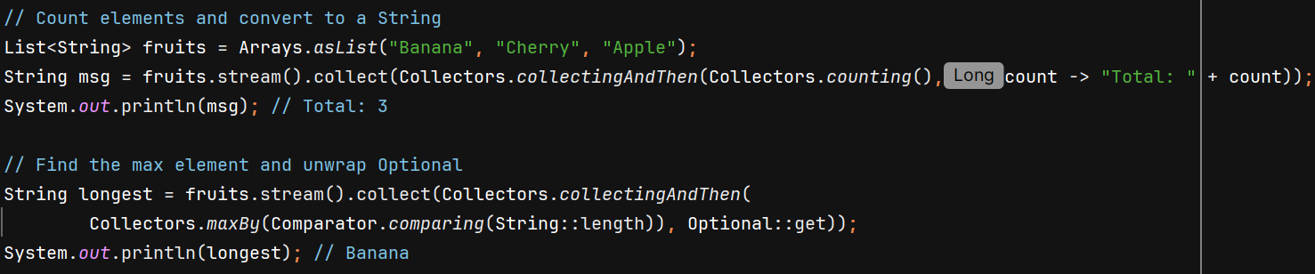

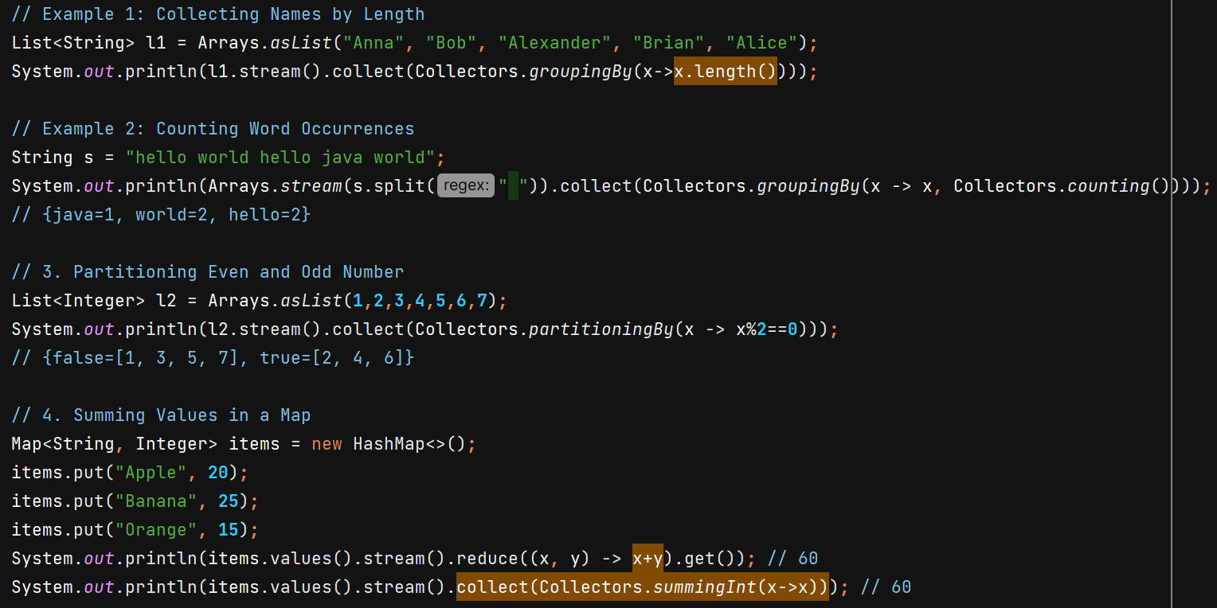

**Collectors.toMap()**

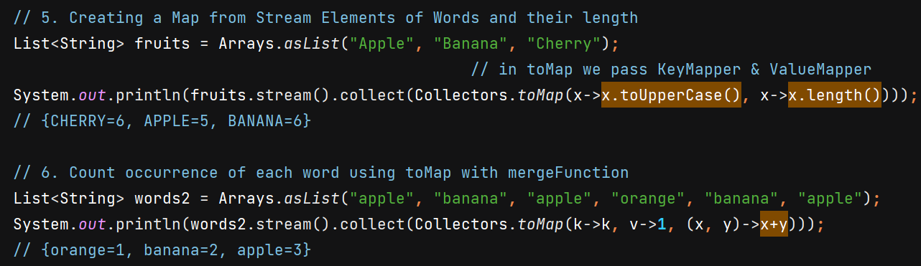 here if we don’t pass mergeFunction then we’ll get duplicateKeyException so we must provide way to handle duplicate key values using mergeFunciton

4th argument of Collectors.toMap() is the supplier where we can specify the Map we want.

**Primitive Streams**

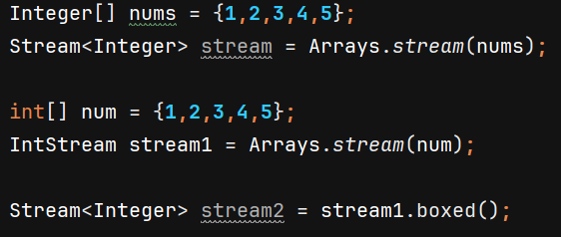

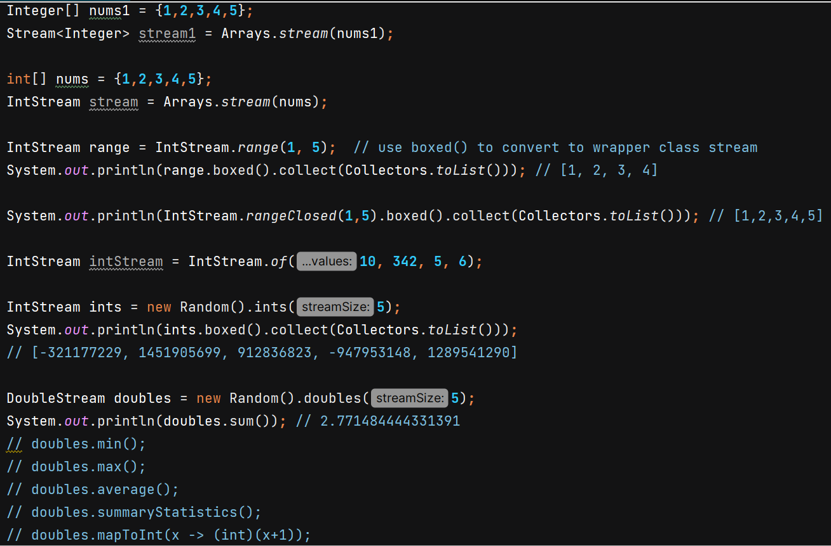

**Interview ques**

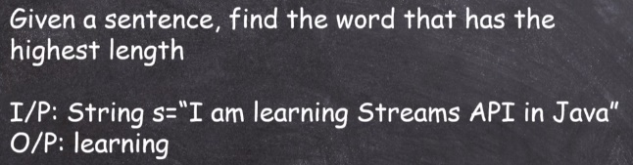

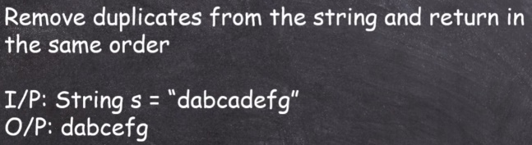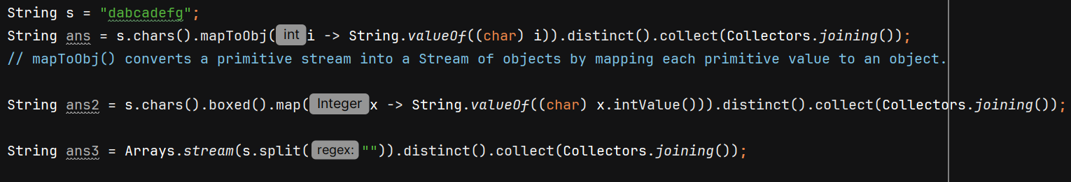

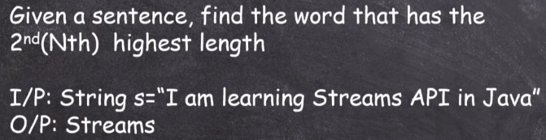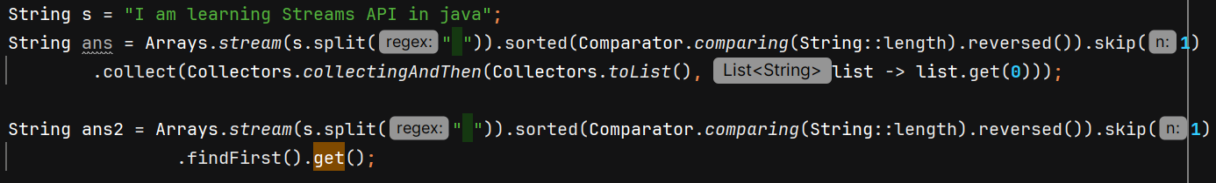

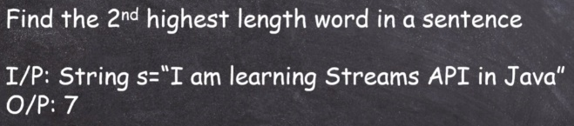

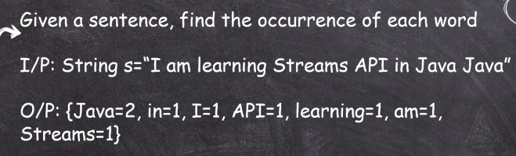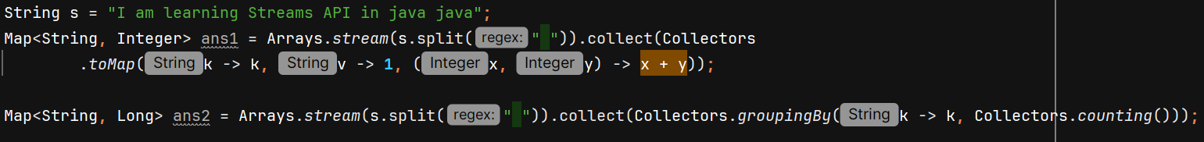

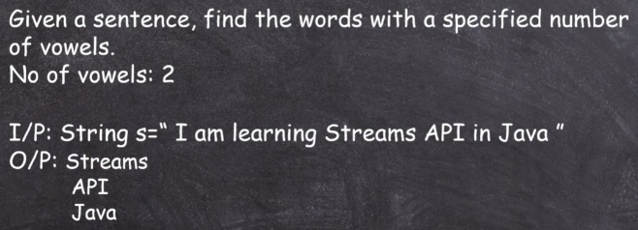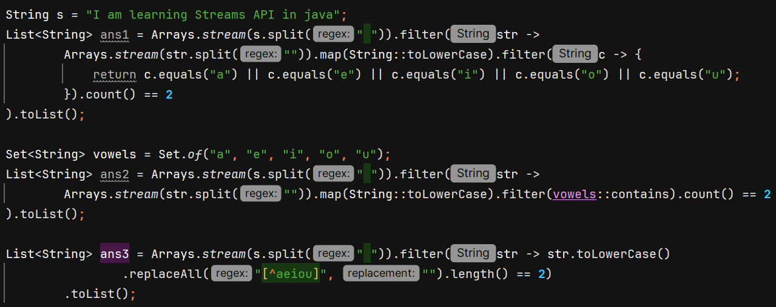

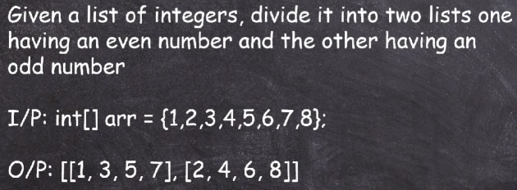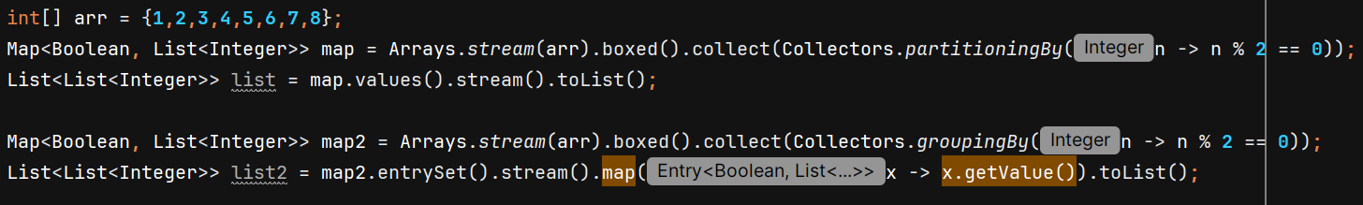

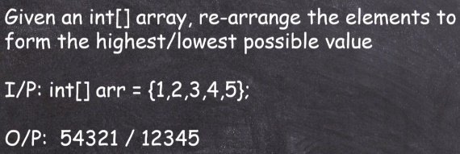

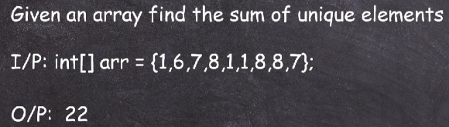

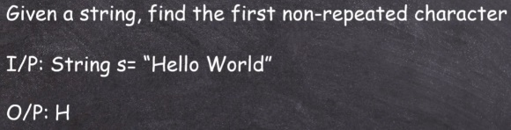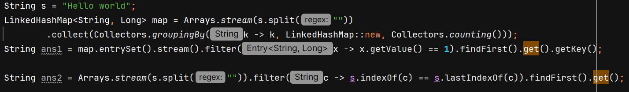

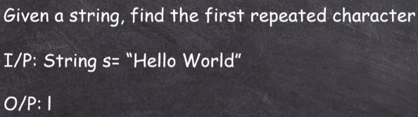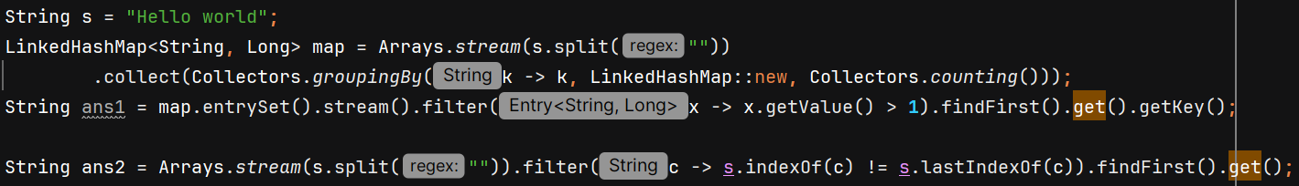

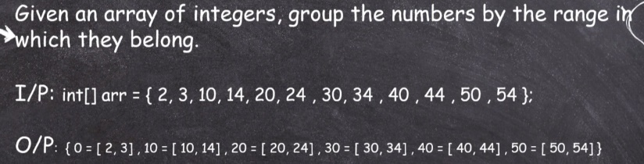 

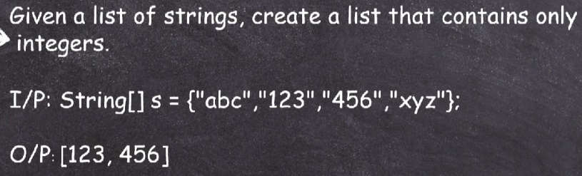

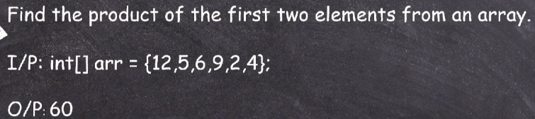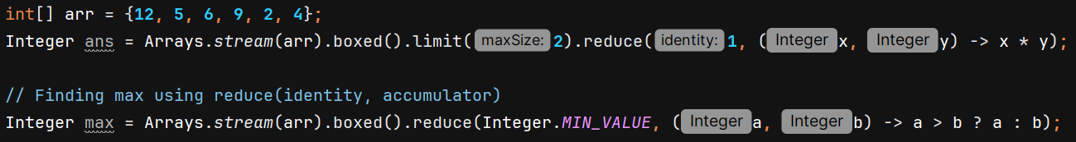

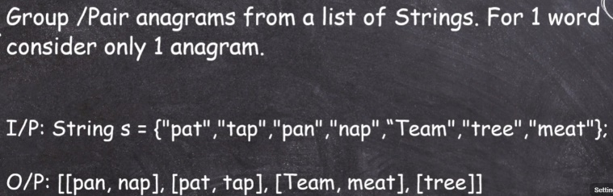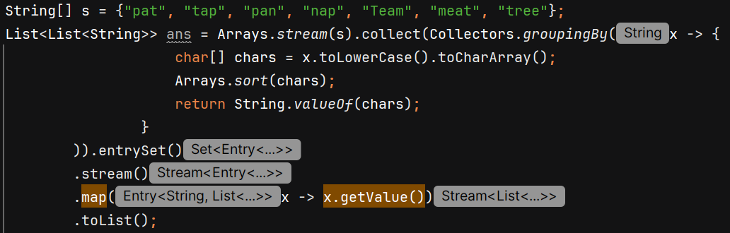

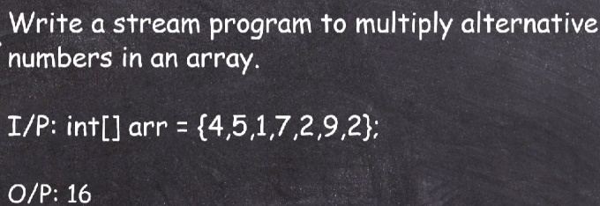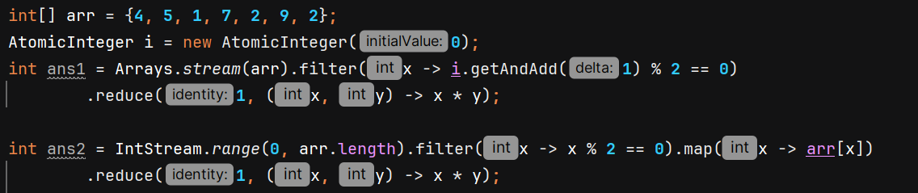

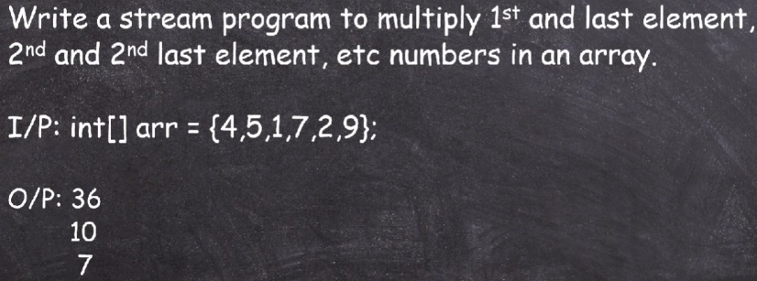

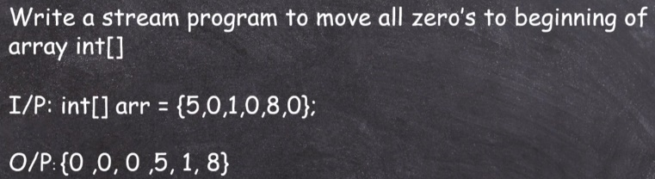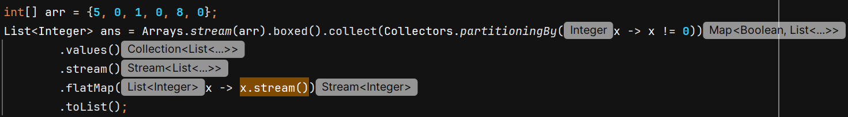

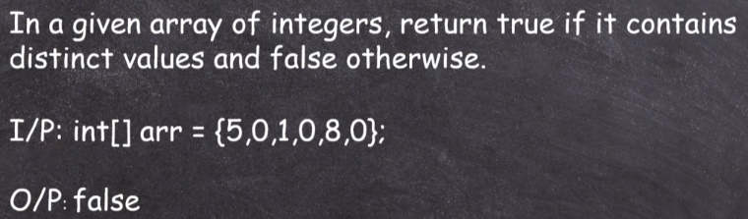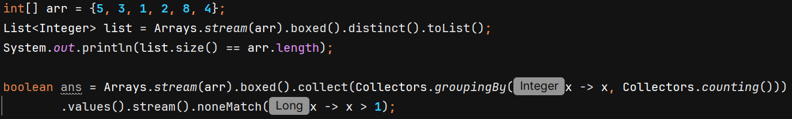

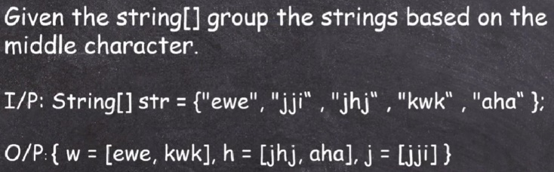

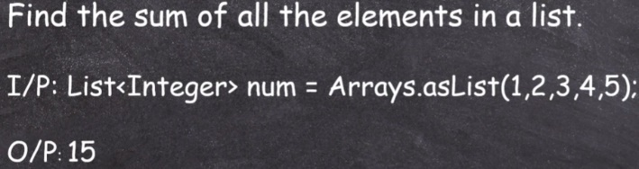

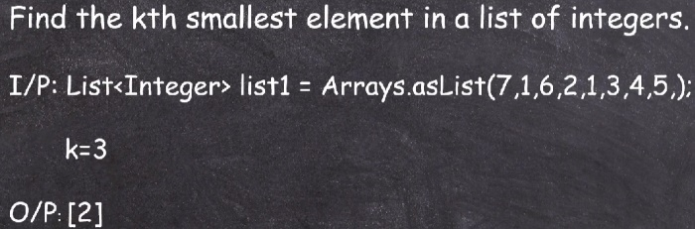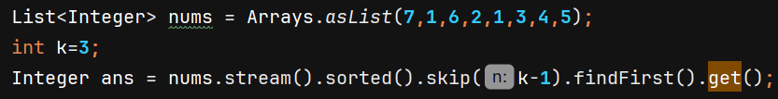

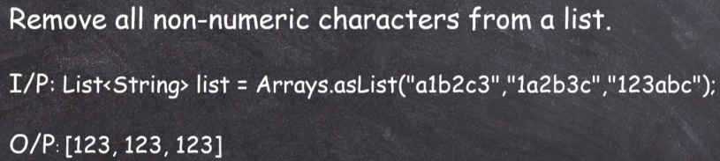

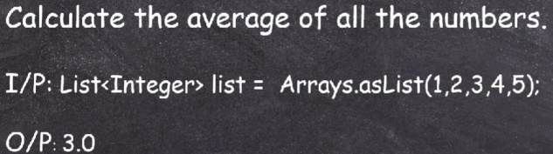

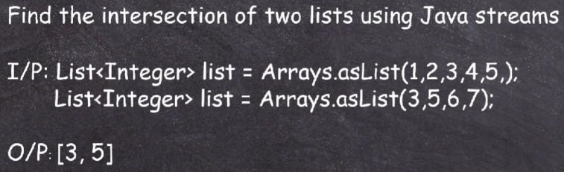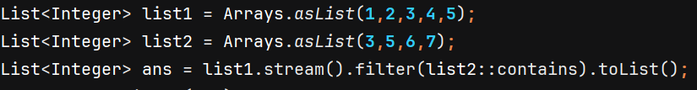

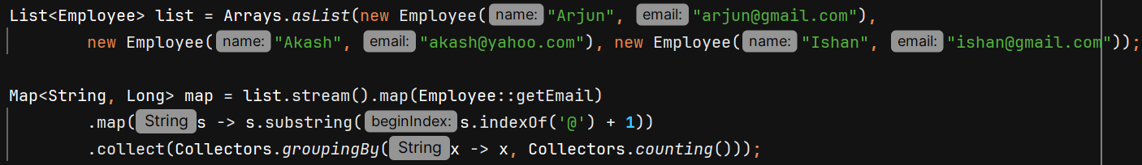

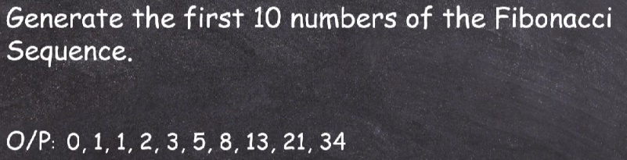

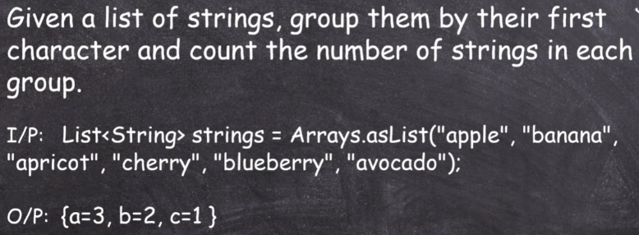

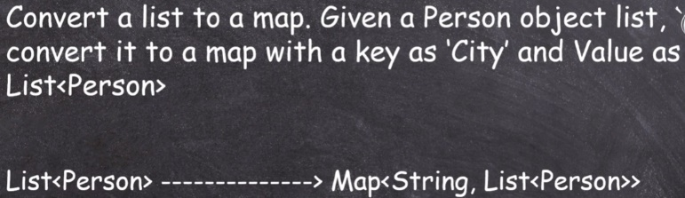

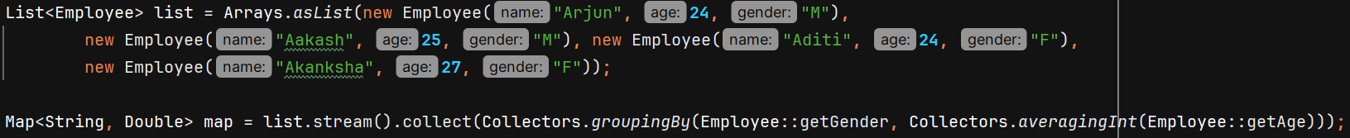

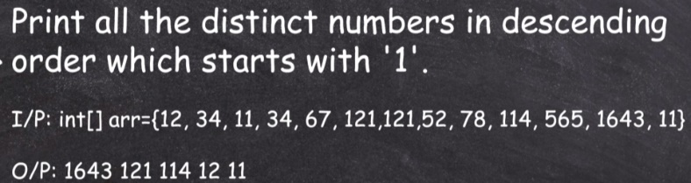

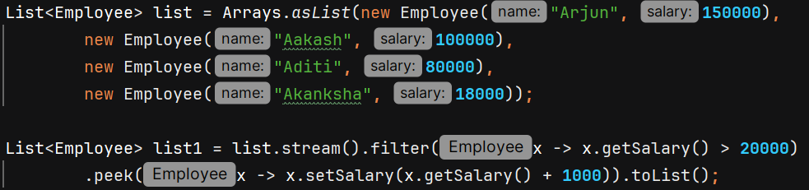

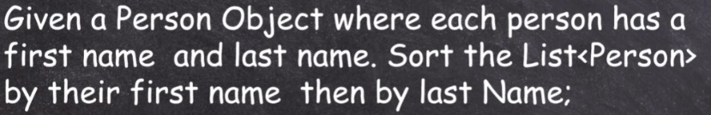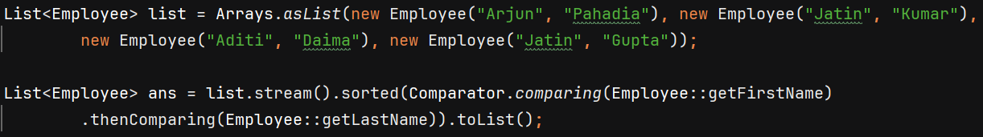

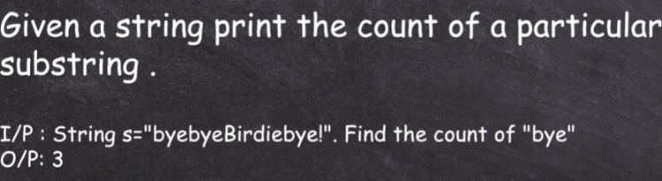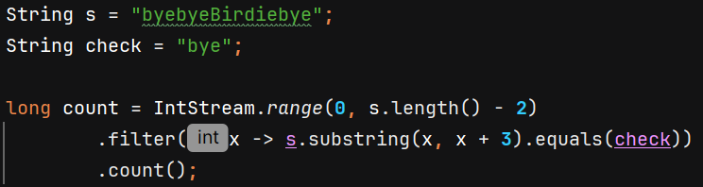

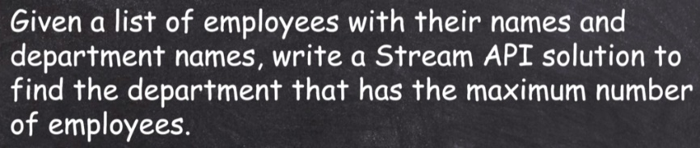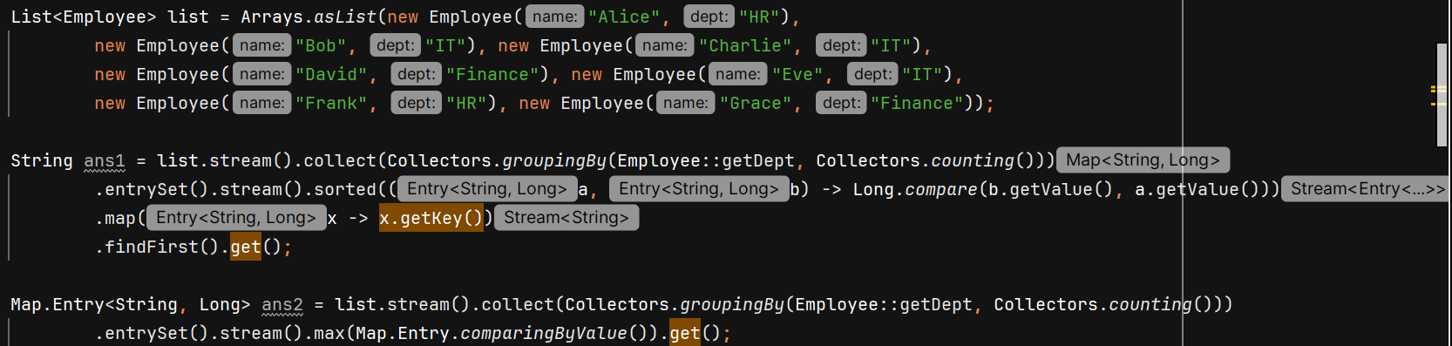

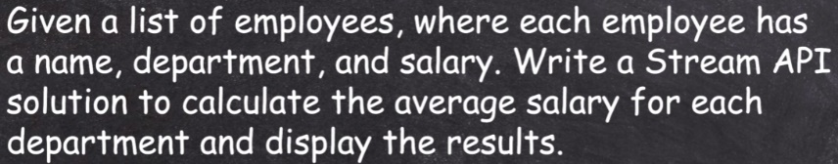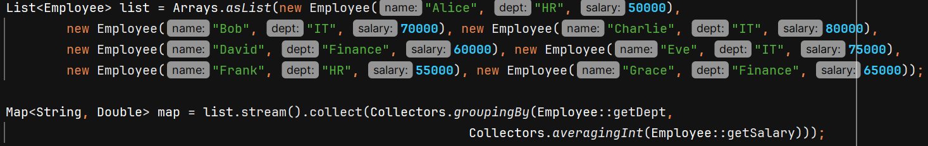

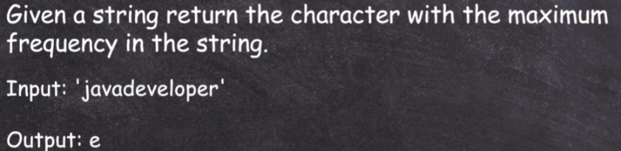

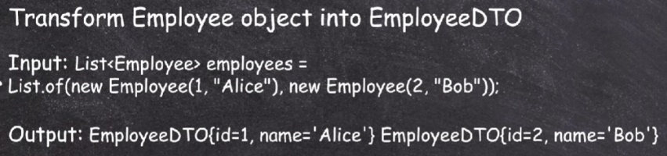

**Internal working of Hashmap and Implementation**

Let’s say we want to store a key-value pair.

Basic approach is to store it like – 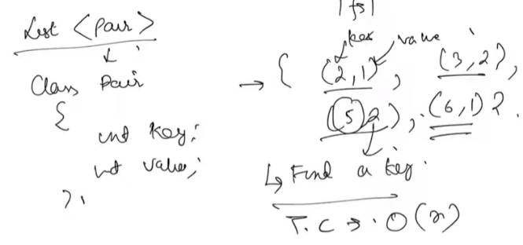

But if we want to find a key in O(1), we’ll do something like this – 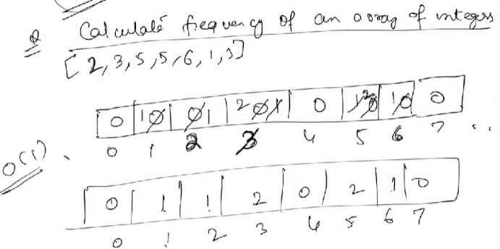

But there is one problem – what should be the size of freq array? We can say that the size = maximum element in input array. But this no can be very huge. 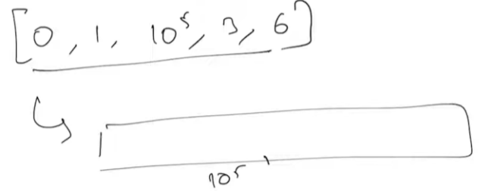 here just for storing 5 elements, we have to create a massive array of 10^5 to maintain frequency.

Improvement – instead of creating array with size = max element, we’ll create Bucket array with some initial size let’s say 20.

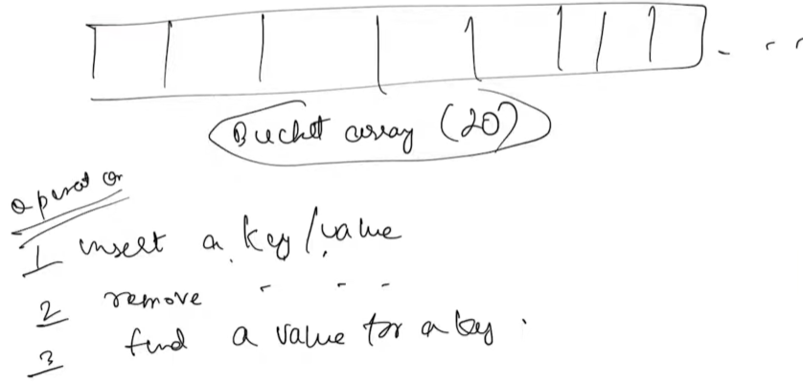

To insert a Key, we have to find index in bucket array in which that particular key will go. So, we need to convert this key 🡪 some index. We do this conversion using some hashfunction.

Hash function gives us Hashcode but that value can be outside the range of bucket array so we all use compression function to fit that Hashcode into bucket size.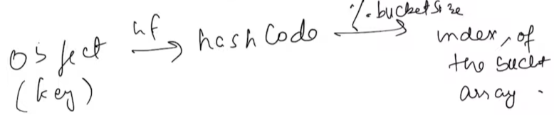

If in the same index of bucket array, multiple keys try to enter then we’ll have Hash Collision. That’s why its imp to have a good hashfunction so that values come out to be uniformly distributed so that you minimize the Hash collisions.

Ways to deal with Hash collision –

* Closed Hashing / Separate Chaining
* Open Addressing – If there is some collision then find some alternative index. There are different functions to find alternative index like linear probing, quadratic probing, double hashing, etc.

In Separate Chaining, at every index we store a list of values 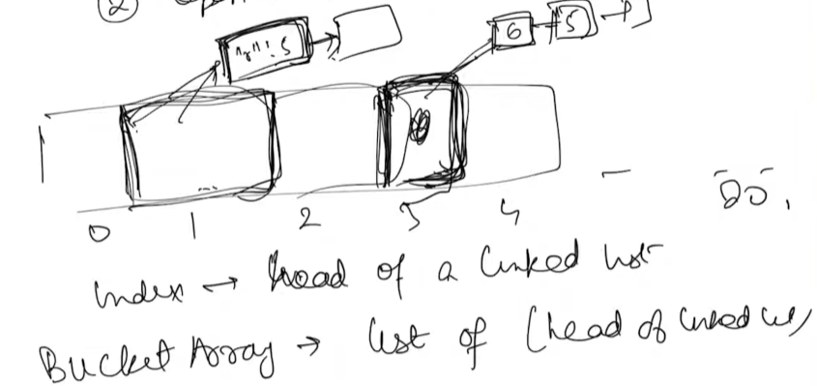

n 🡪 no of entries in hashmap, b 🡪 no of bucket

Time complexity for getKey in worst case will be O(n) if hash collision happens and all entries reside at single bucket index.

The size of linked list should not be more than (n/b) for ideal case when our hashfunction uniformly distribute the entries.

**n/b** is the **load factor**

For java it is 0.75, so HashMap allows the load factor to grow up to 0.75 Once it exceeds 0.75, the map resizes (rehashing).

Rehashing 🡪 our goal is to decrease n/b value so we double the bucket size. After increasing the size, we reshash the values. Time Complexity = O(n) but it happens at small intervals.

Average TC for getKey() will be O(1)

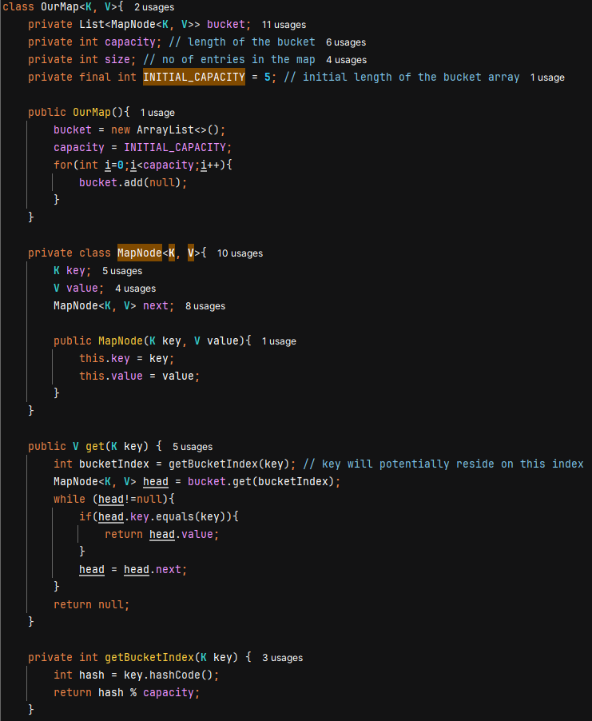

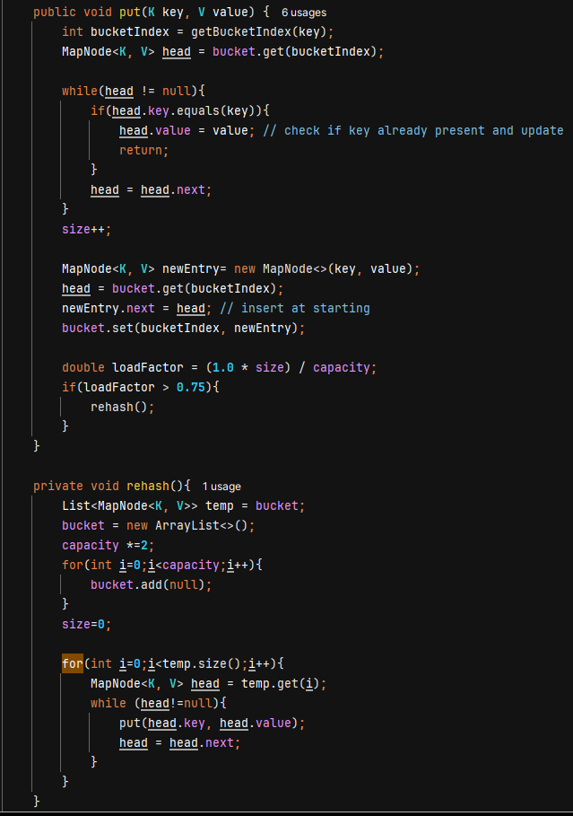

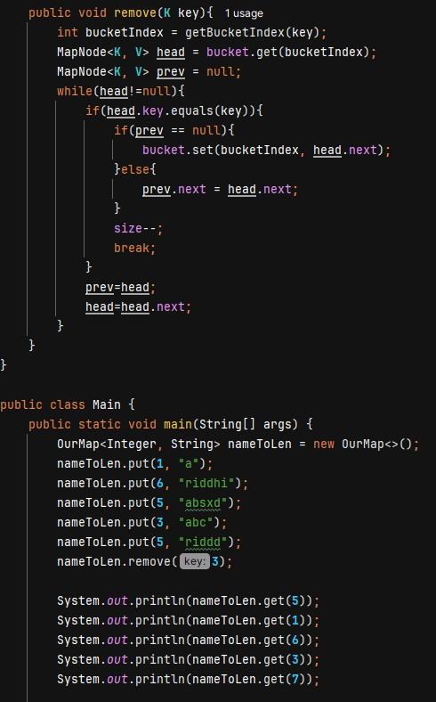

**Interview Questions**

**Q: Sort HashMap based on values using Streams API**

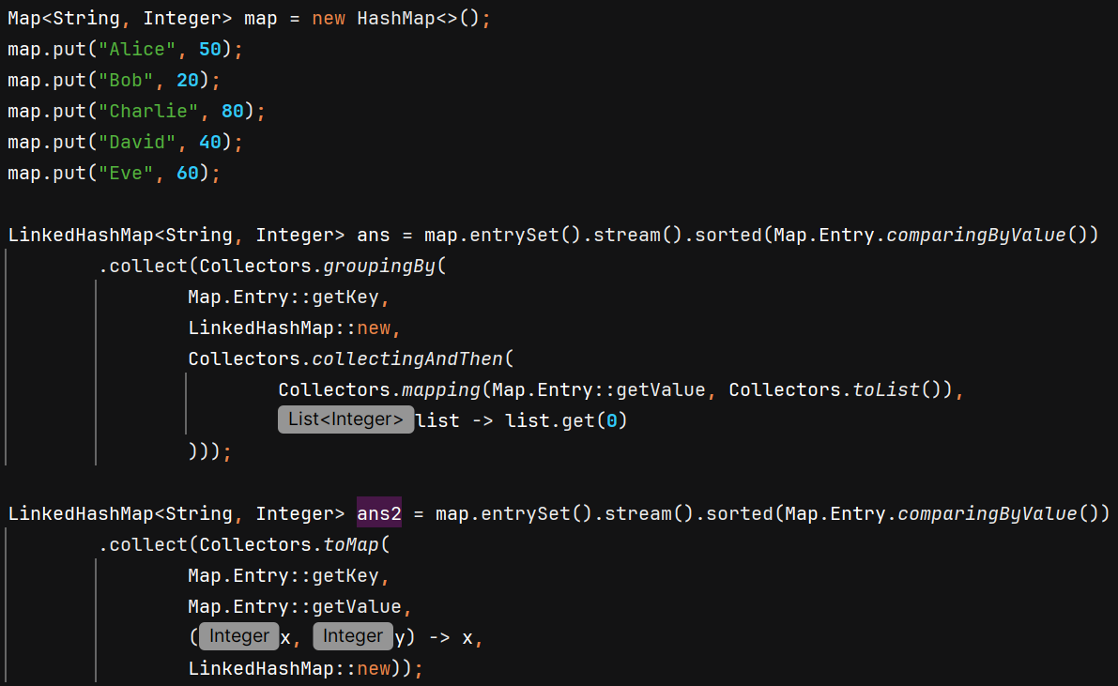

**Q:** 

Immutable 🡪 which cannot be changed after initialization

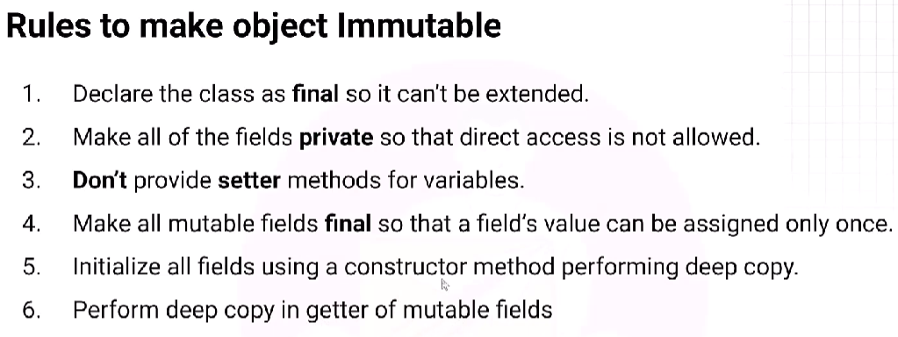

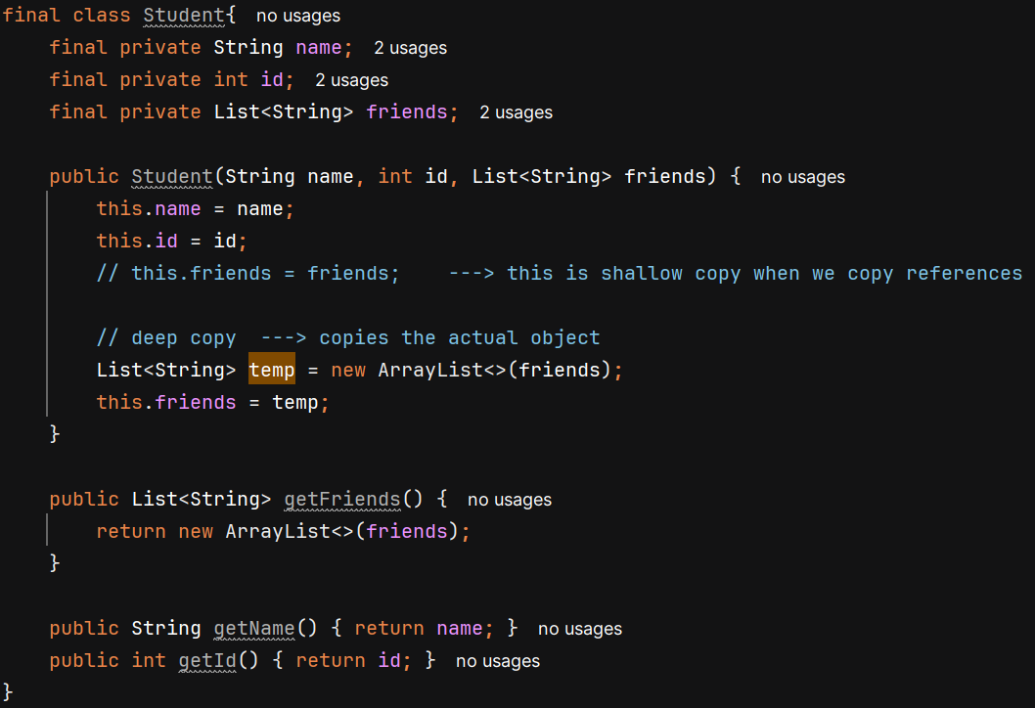

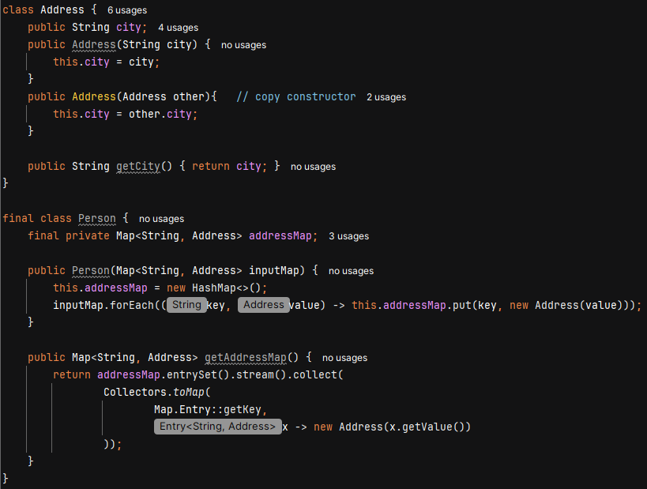

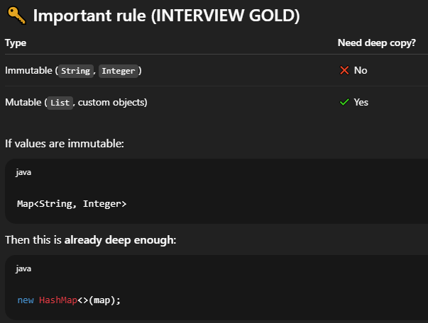

**Q: Is Java a pure object-oriented language?**

No, because –

* Java has Primitive data types that are not objects: int, char, boolean, double, float, etc. In pure OOP languages 🡪 everything is an object
* Java has Static methods and vairables – which belong to the class, not an object.

**Q: Serialization and De-Serialization**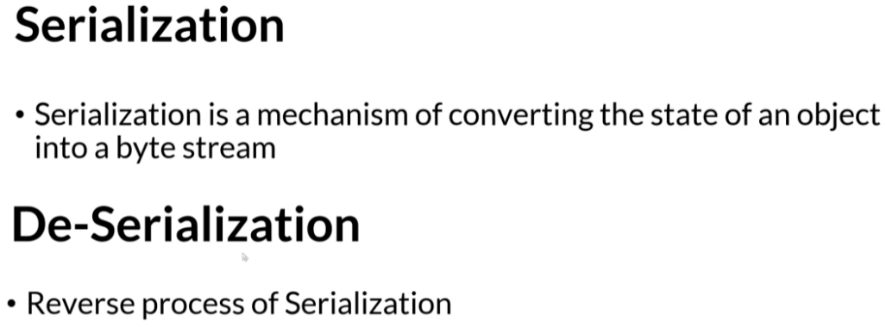

* For an object to get Serialized, its **class should implement Serializable interface** (It is just a marker interface)
* Static and transient fields are not serialized.
* Used for sending objects over network
* Java **serialization works directly on fields**, not via methods so Getters/Setters are NOT needed
* JVM uses **serialVersionUID** to ensure compatibility
* In deserialization, object is created without calling constructors.

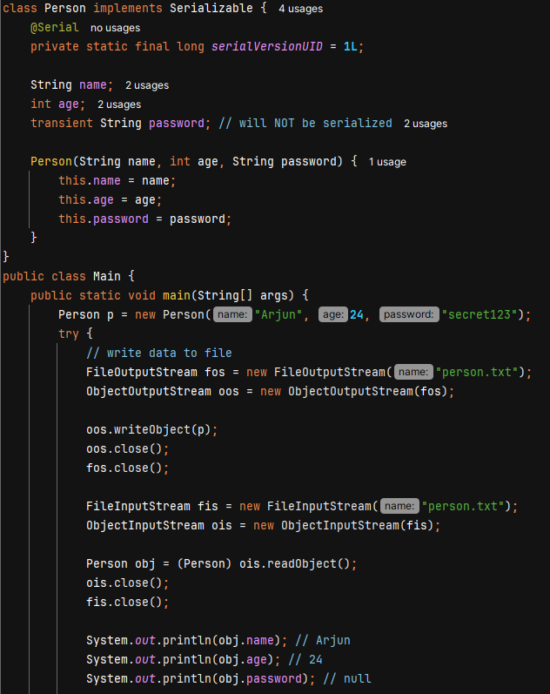

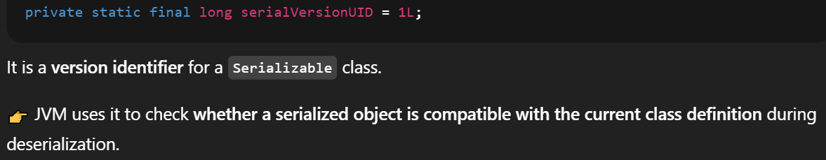

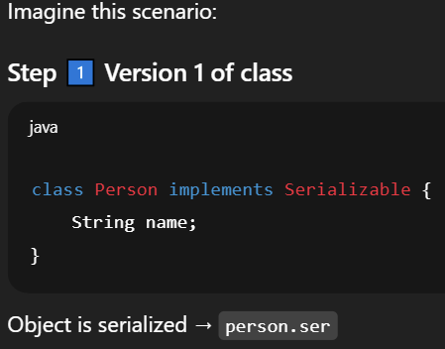 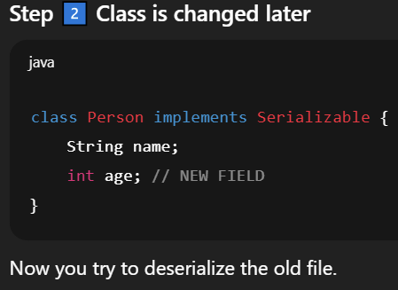

Without serialVersionUID, JVM automatically generated a UID based on class name, fields, methods, modifiers. So, after change old UID ≠ new UID 🡪 JVM throws InvalidClassException.

With serialVersionUID, JVM sees same UID 🡪 allows deserialization and age is set to default 0.

We cannot change field name JVM looks for exact field name – serialVersionUID

**Q: Record**

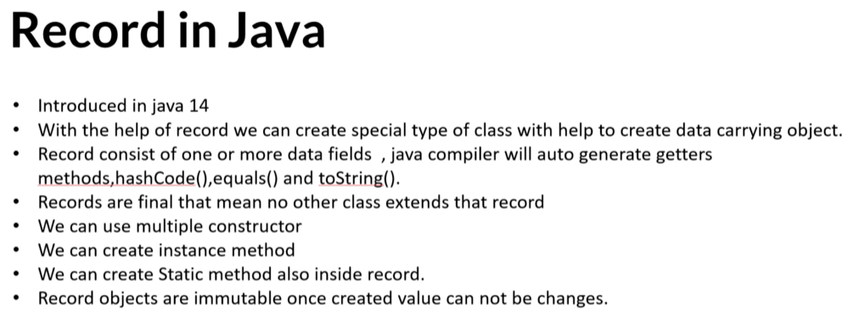

Record can implement interface but cannot extend any class.

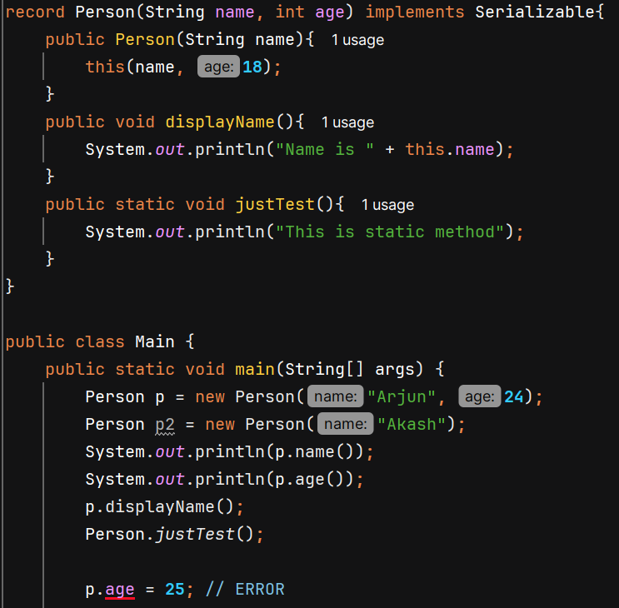

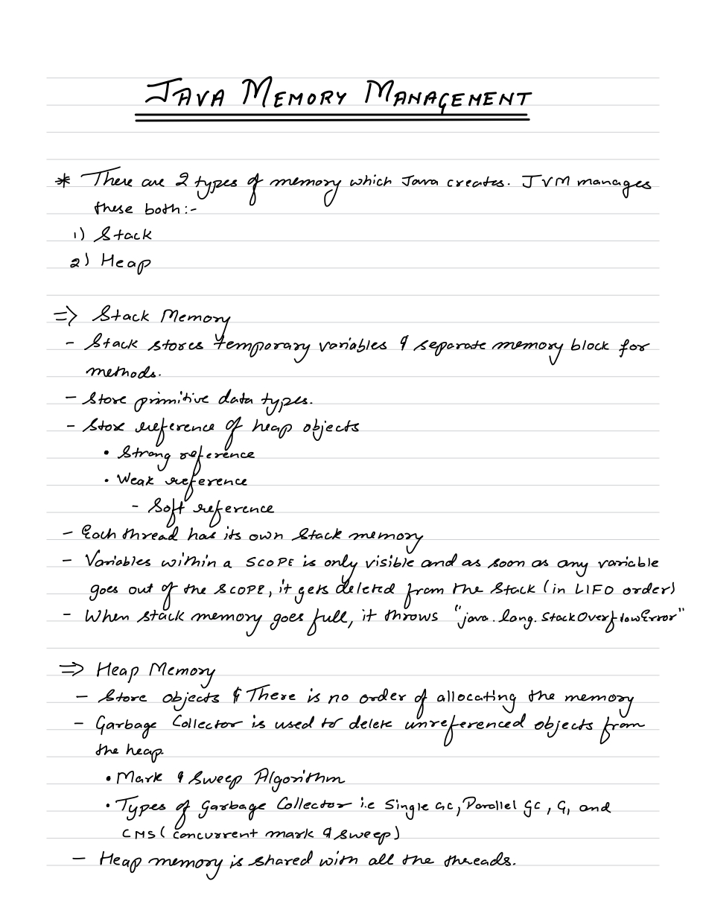

By memory we mean RAM

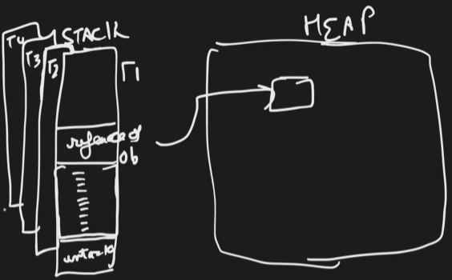For each method, stack memory stores a memory frame for it and all variable inside that method are stored in that memory frame.

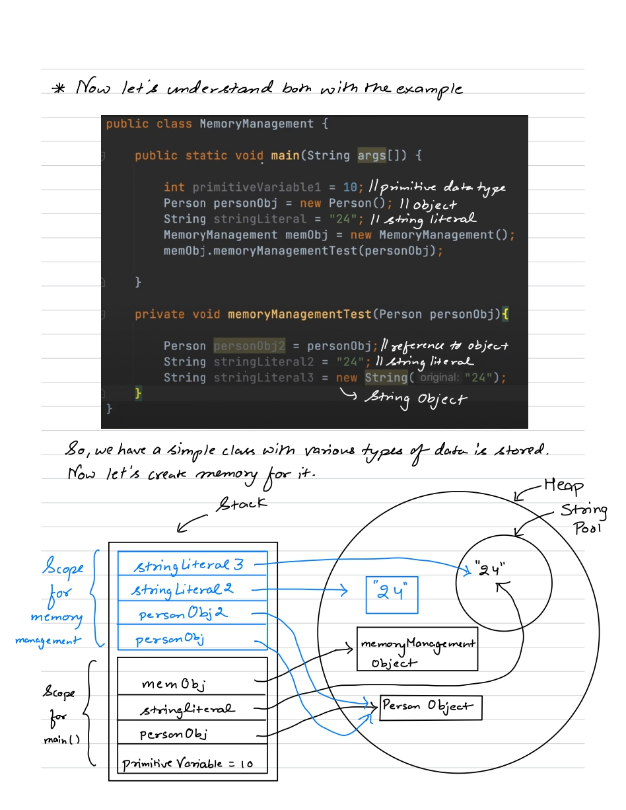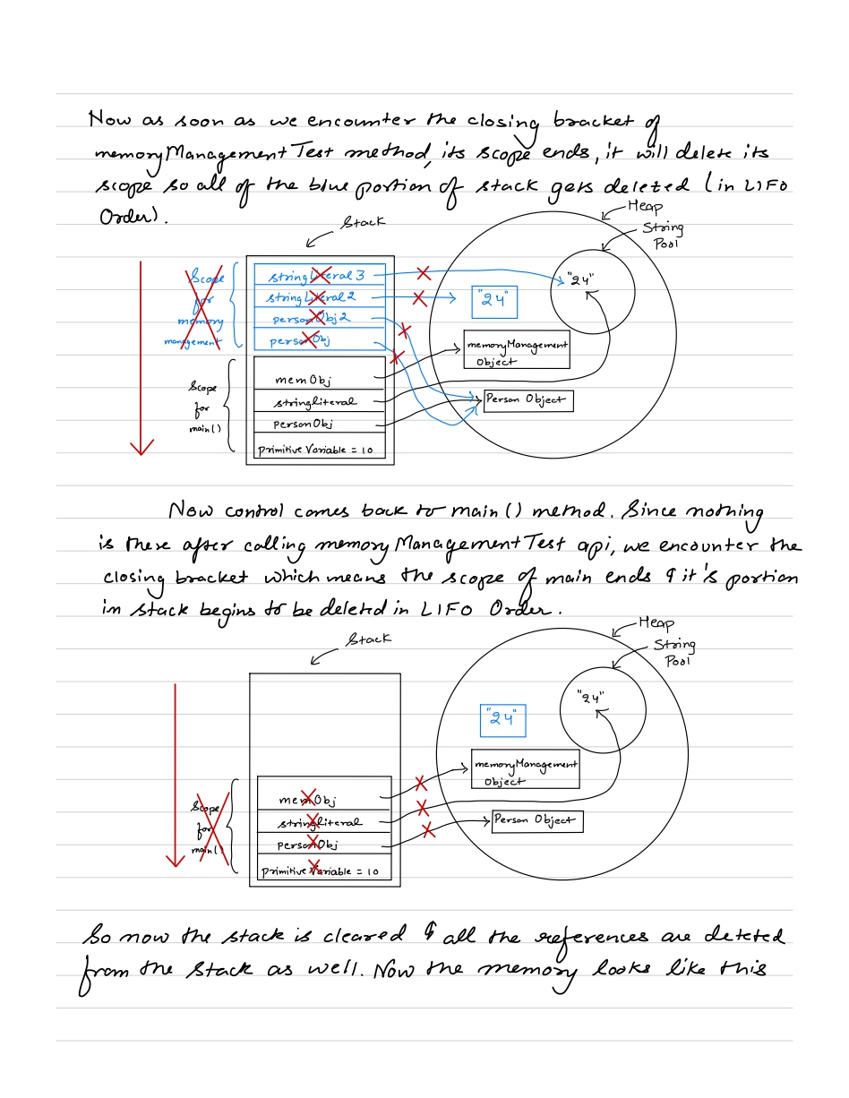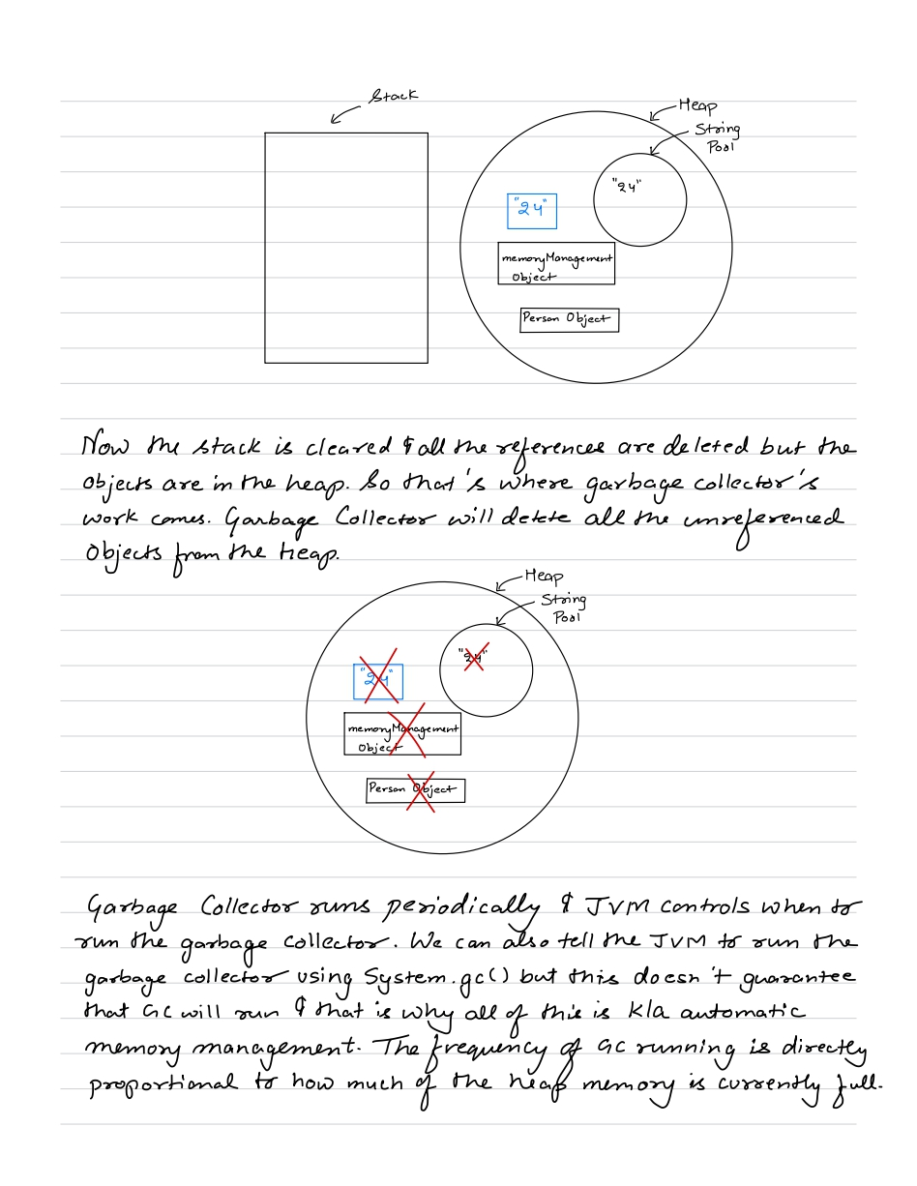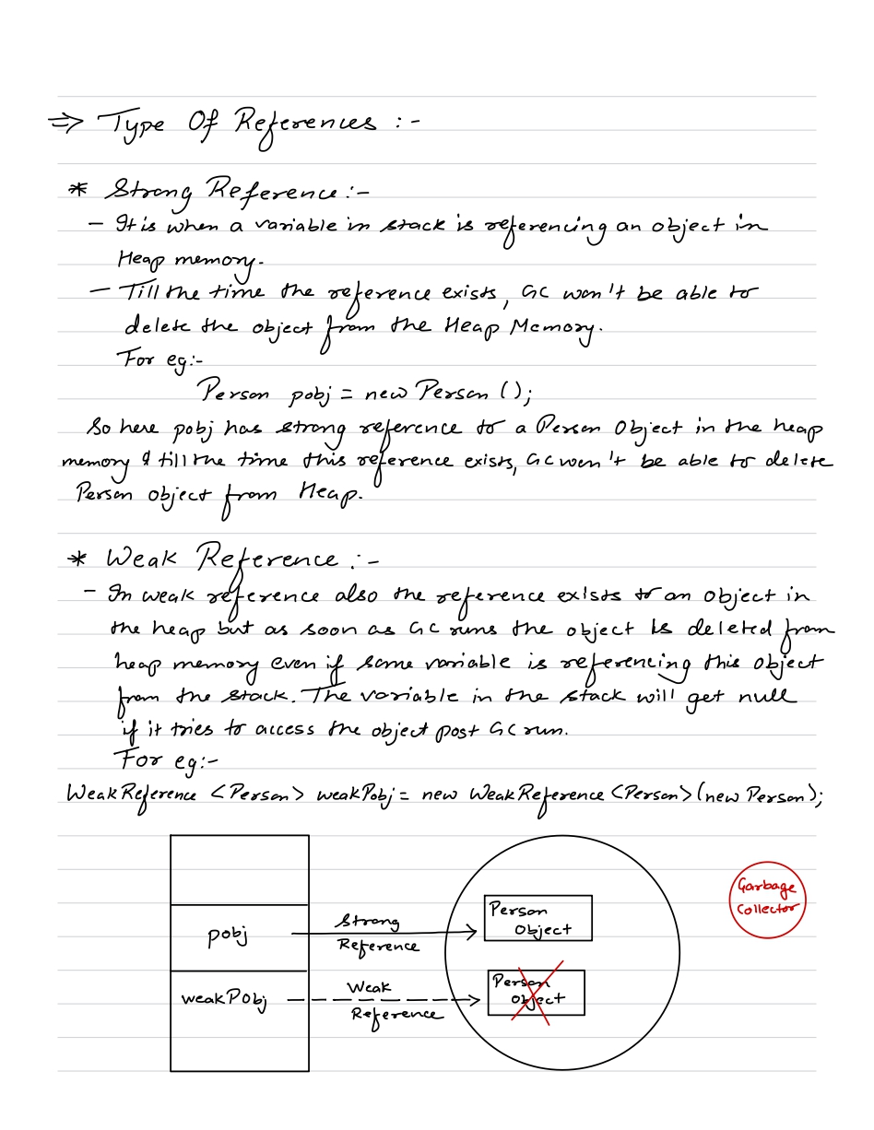



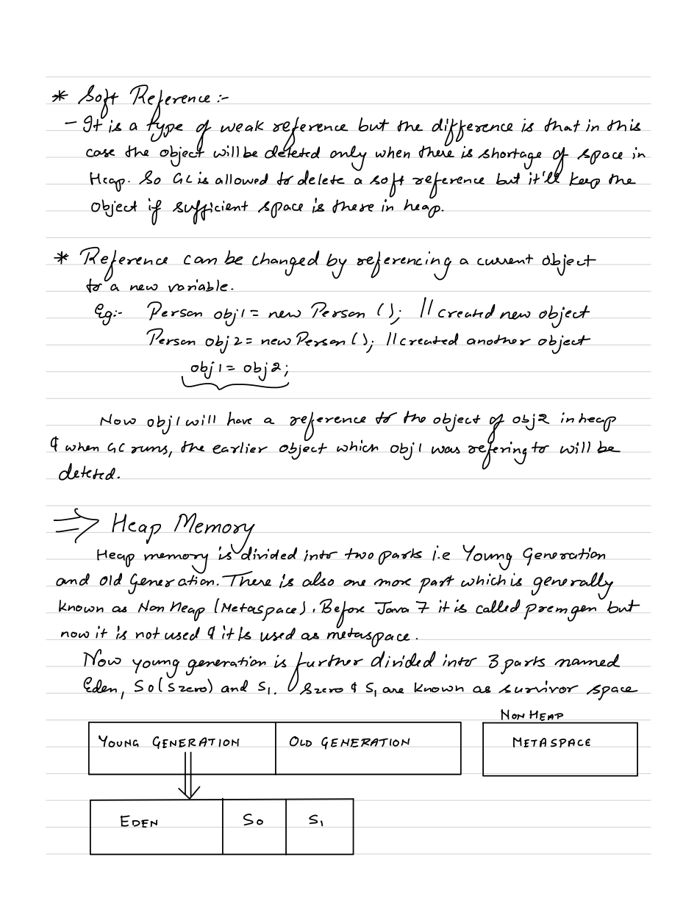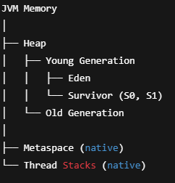 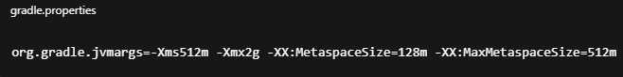

PremGen (before Java 8) was considered a part of Heap memory.

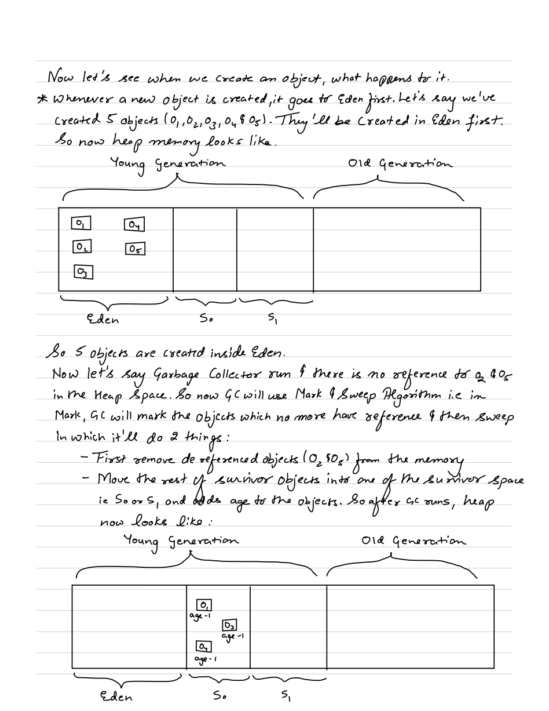Young Generation uses Minor GC to clean short-lived objects. It happens very fast and runs more frequently. Pause time is less.

Old Generation uses Major GC to clean long-lived objects. It is time taking and runs less frequently.

During GC, JVM freeze application threads to get a consistent view of object references. This happens in both Major and Minor GC. But for Major GC pause time is longer.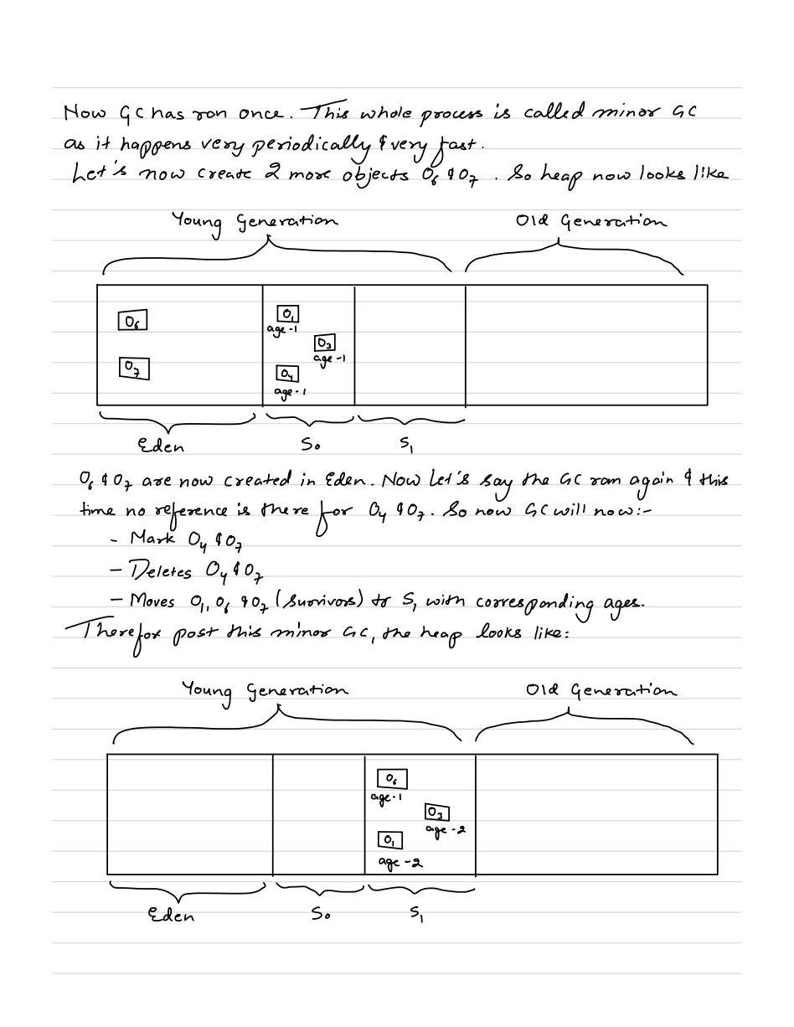  
  
  
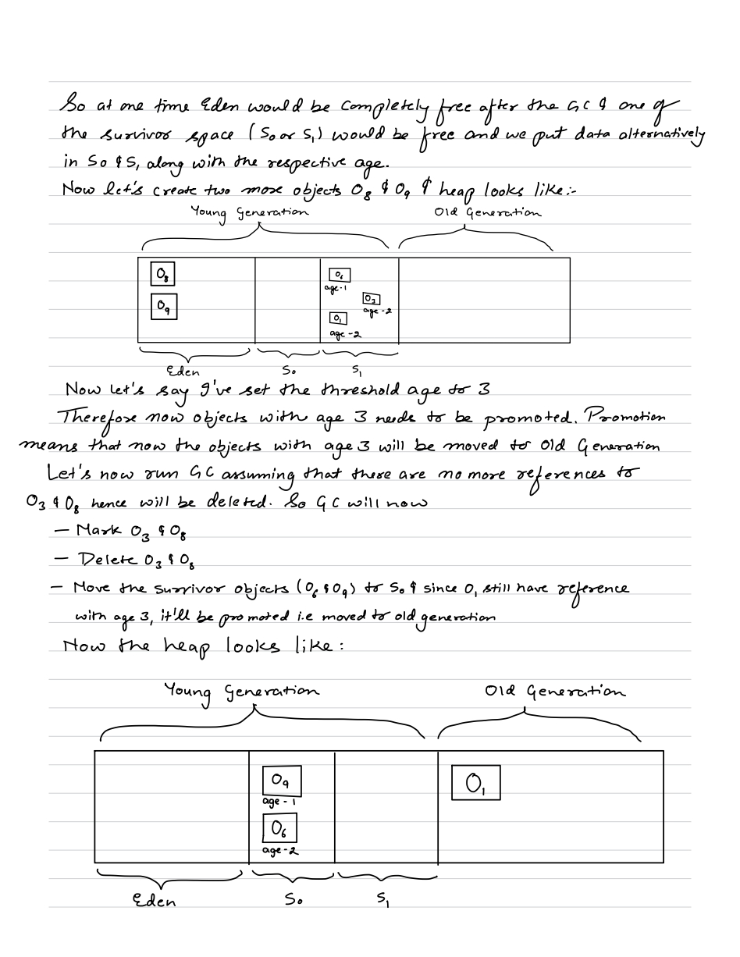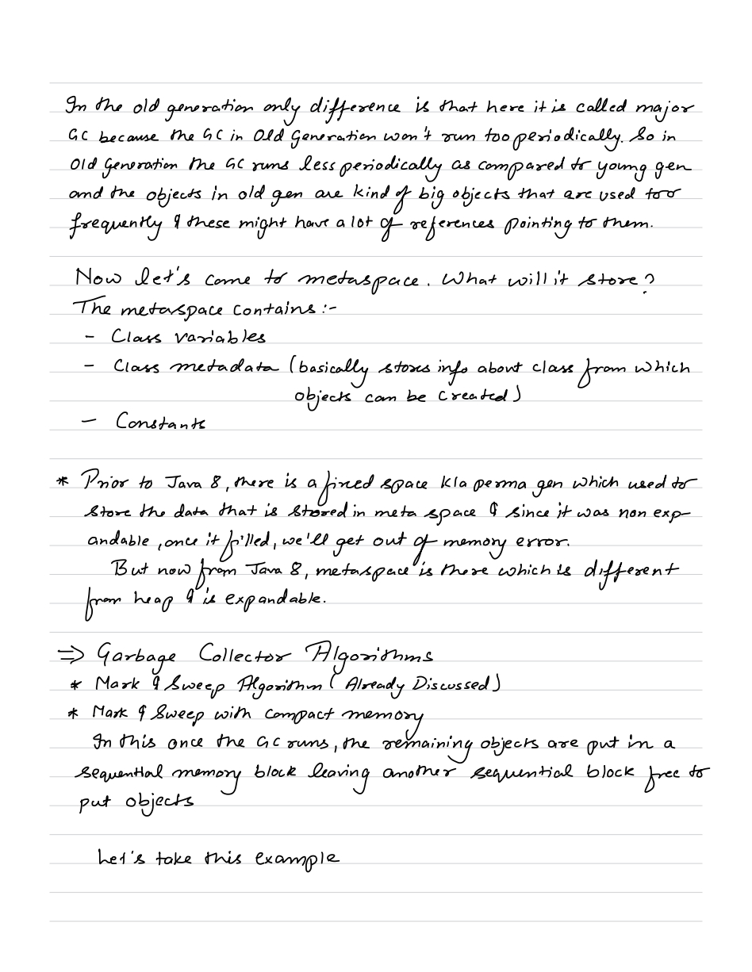  
  
As soon as JVM needs certain class, it will load in metaspace and remove it when it doesn't need.  
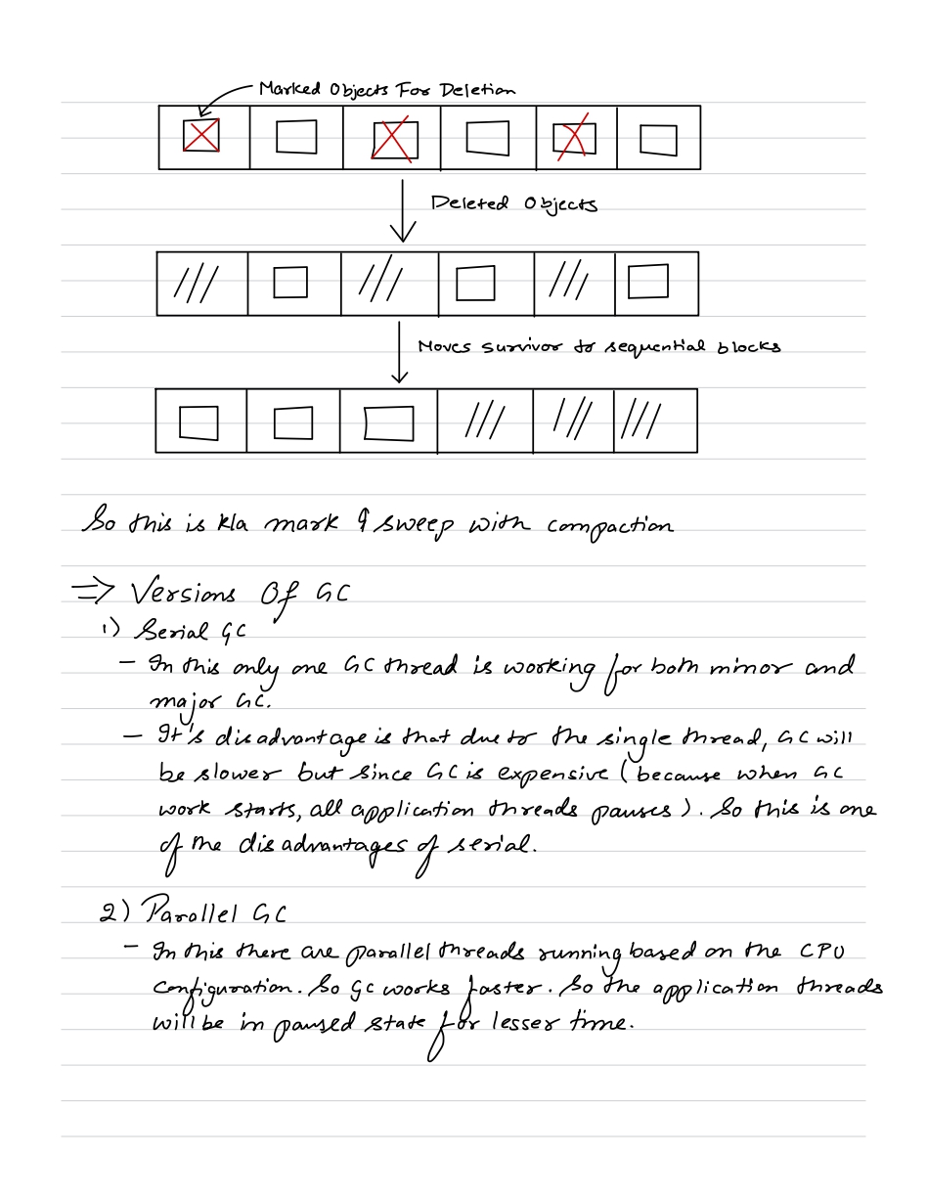  
  
Parallel GC is default in Java 8.   
  
In CMS, concurrent GC threads run alongside application threads to minimize pause time by Major GC. But it does not gaurantee that application threads will not stop.

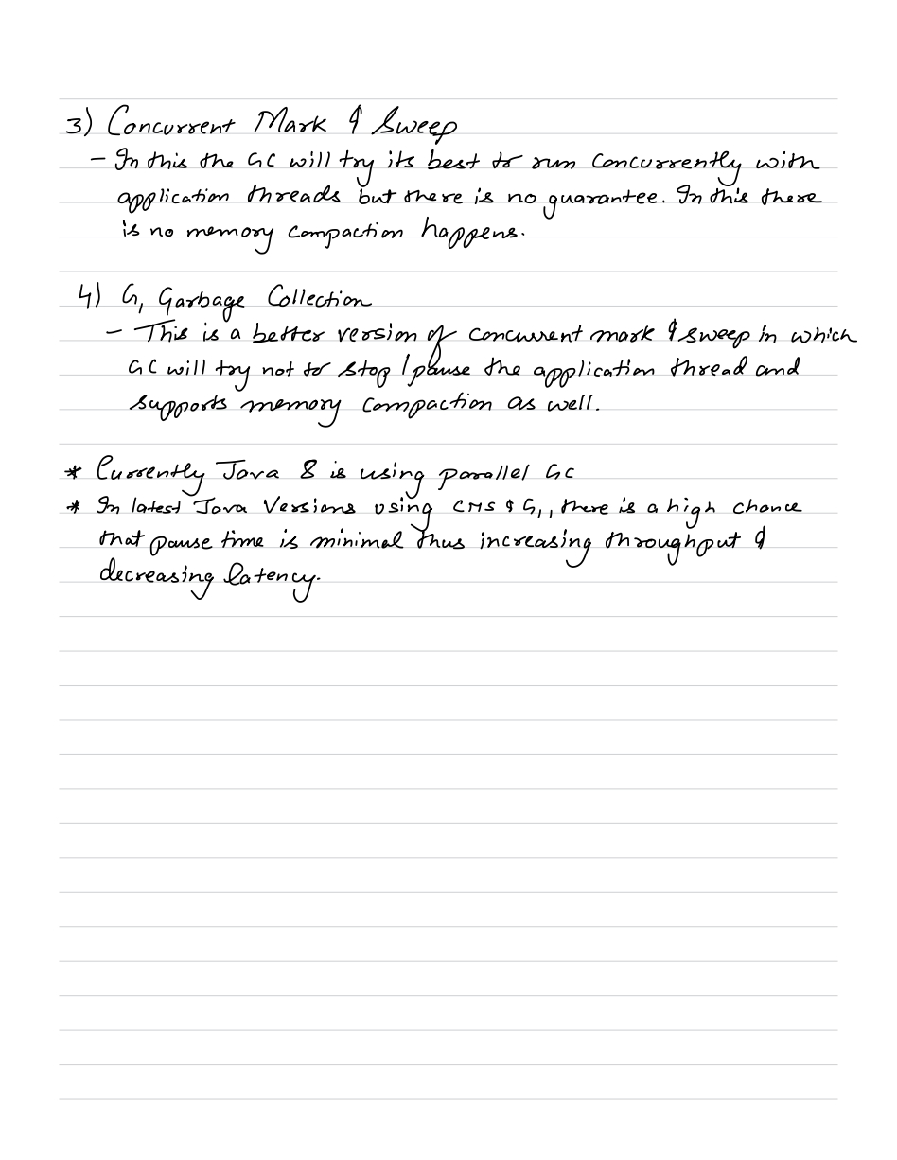

G1GC is default in java 17/21/22/23.

**ZGC** is a low-latency garbage collector that performs concurrent marking and compaction to keep GC pauses under 10 ms, even for very large heaps.

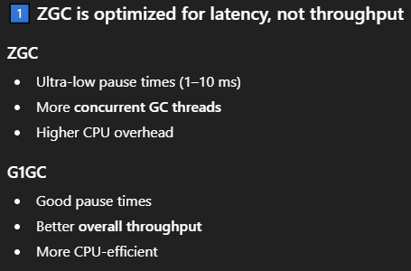

We configure which GC to use in **gradle.properties** file like –

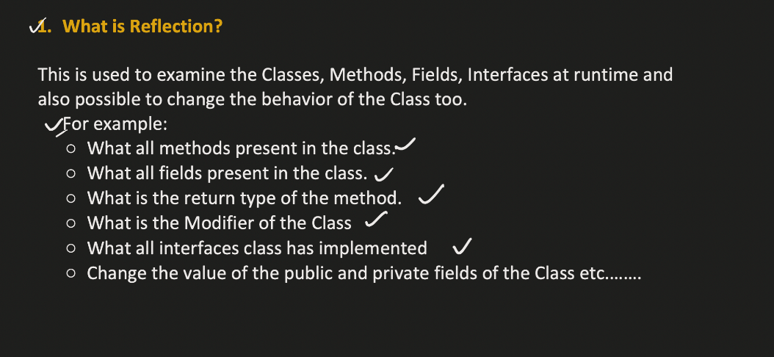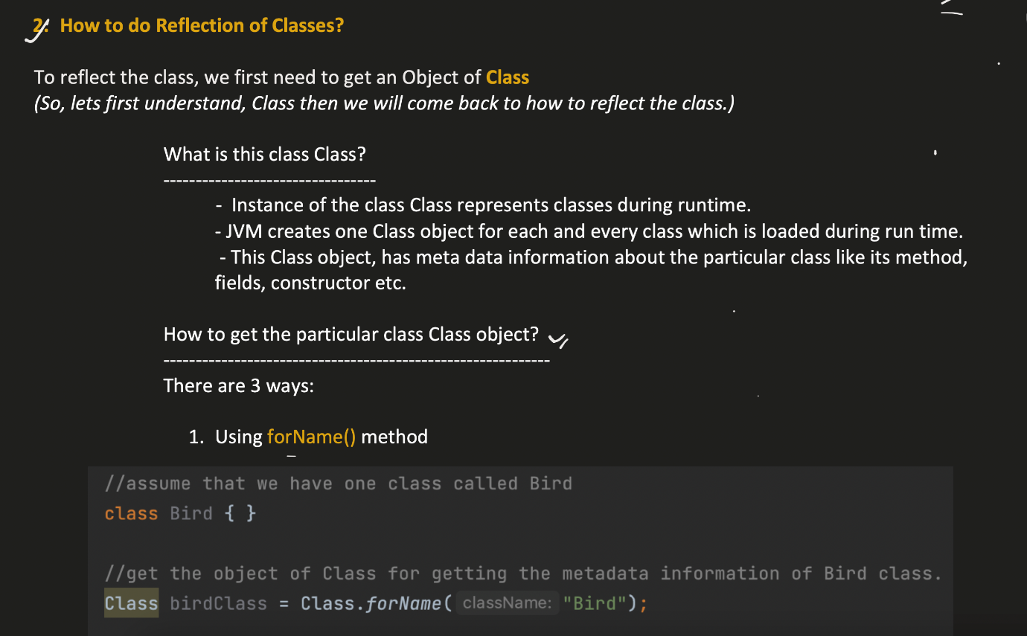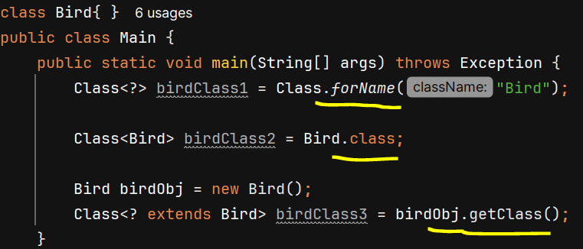

**Reflection of Classes**

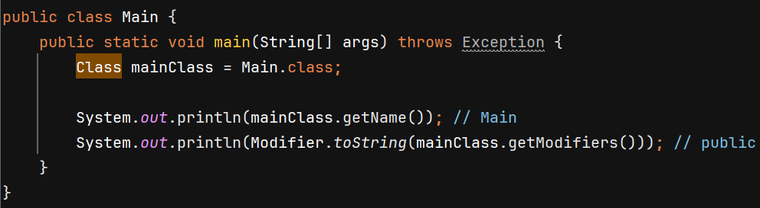

mainClass.getModifiers() return public because class is public.

**Reflection of Methods**

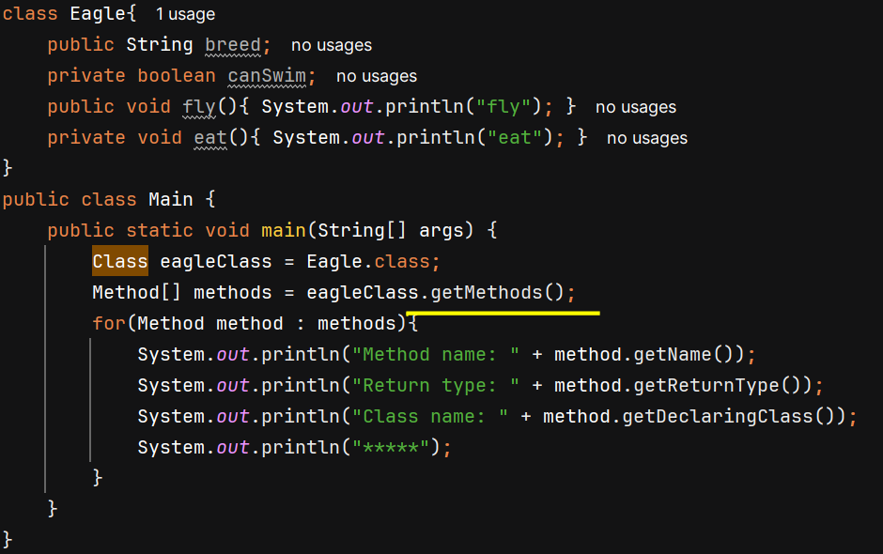

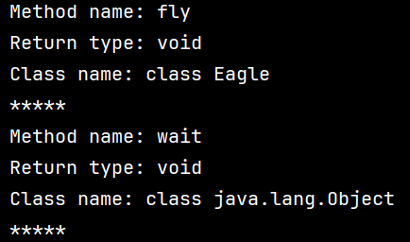

Every class is internally child class of Object.

getMethods() will return all the public methods in that class and also in its super class.

getDeclaredMethods() return all public and private methods within Eagle class only

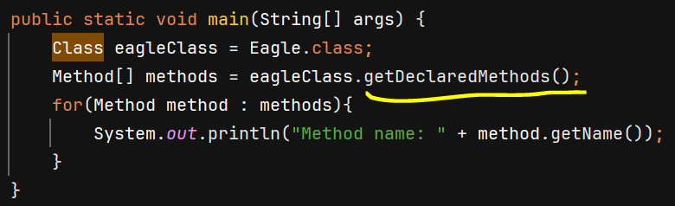 O/P - 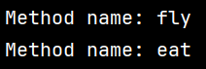

**Invoking Method using Reflection**

To invoke a method, we need object so we get it using **newInstance()** which internally invoke constructor of that class and return its object.

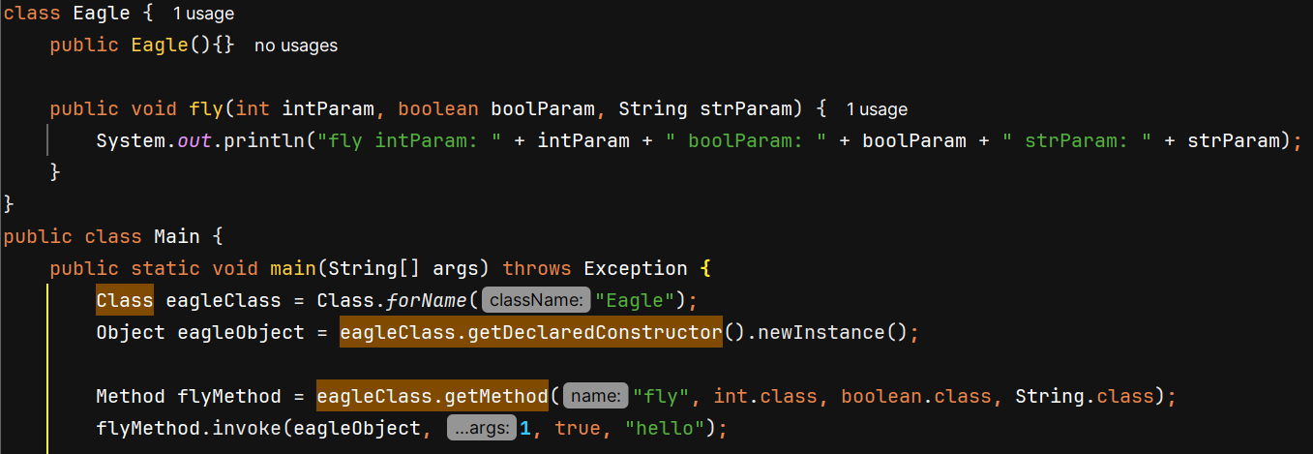



**Reflection of Fields**

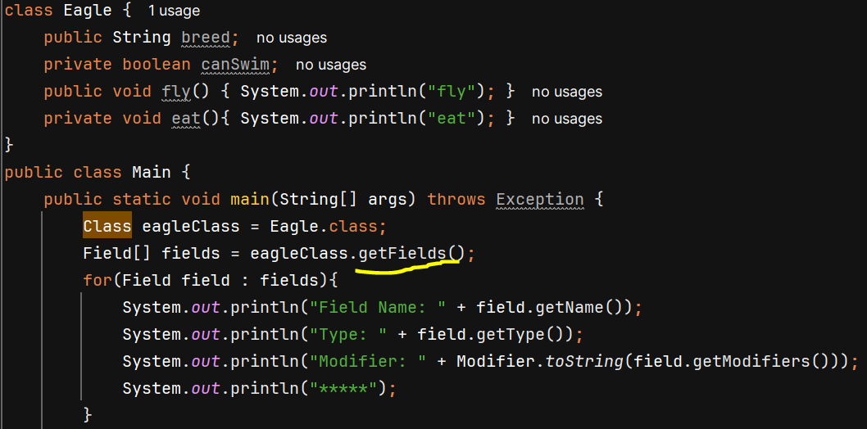O/P – 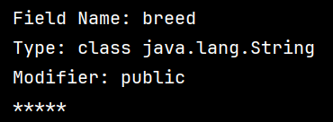

getFields() will only return public fields of class

getDeclaredFields() will return both public and private fields

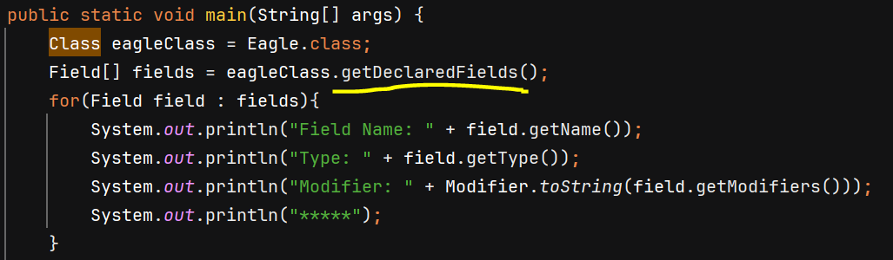O/P – 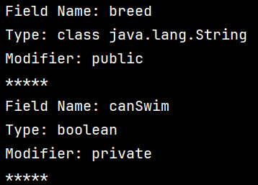

**Setting value of Public field**

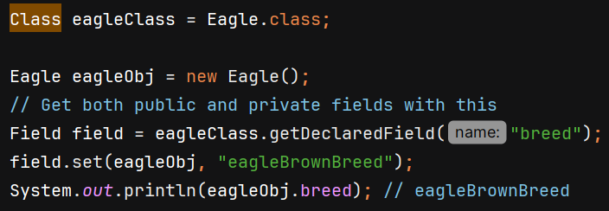

**Setting value of Private field**

Incorrect way – 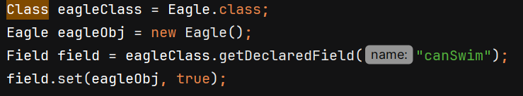

We get exception –

Correct way – 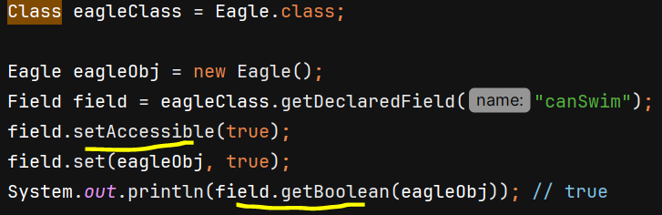

field.setAccessible(true) internally gives us the access of private fields outside the class and we can set its value. This is also disadvantage of reflection.

* Reflection breaks singleton class, and oops concept of encapsulation
* It is slow as it happens at runtime.

**Reflection of Constructor**

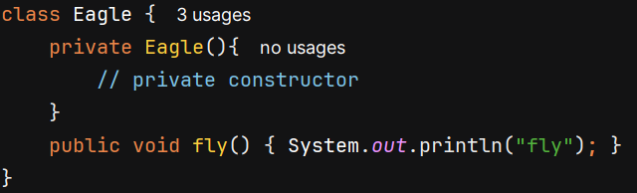

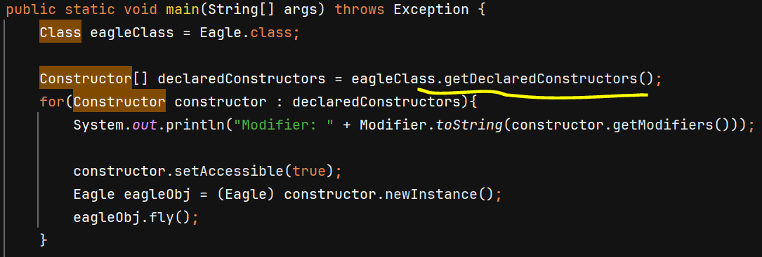

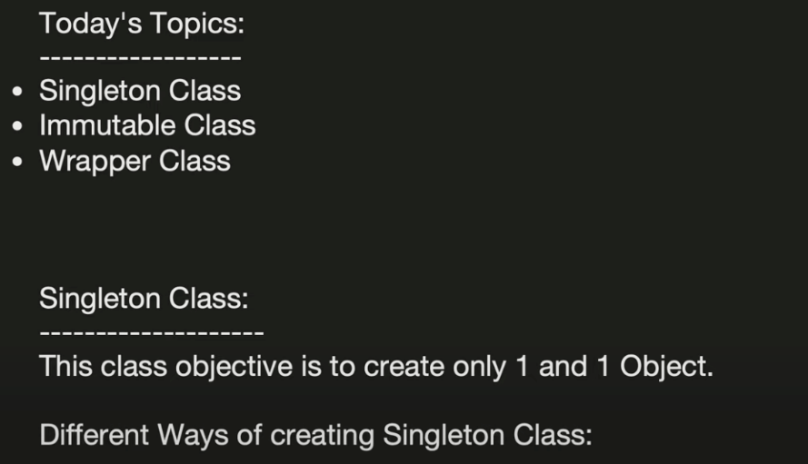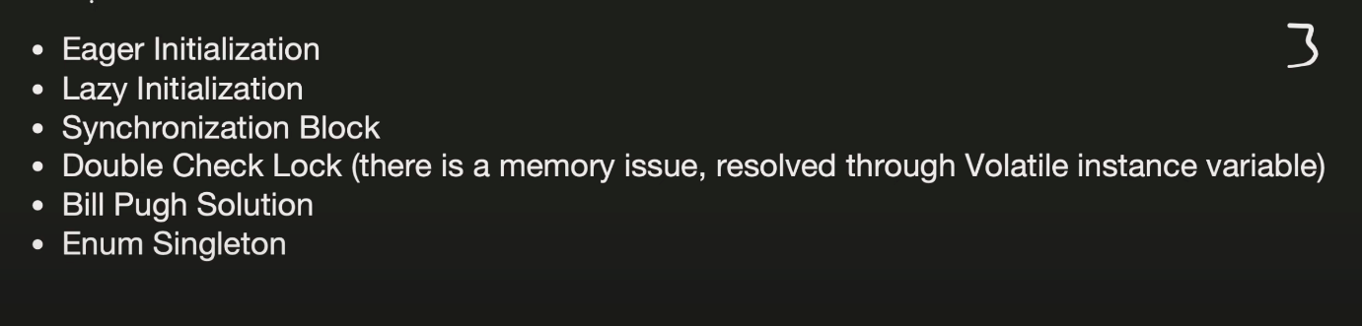

**Eager Initialization –**

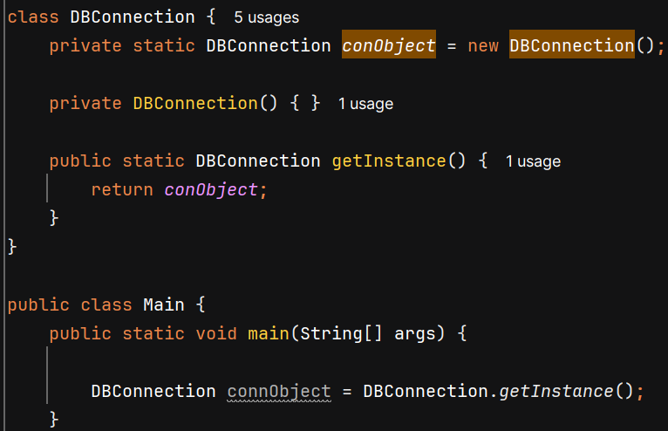

Static fields get initialized as soon as the class is loaded into memory.

**Lazy Initialization –** 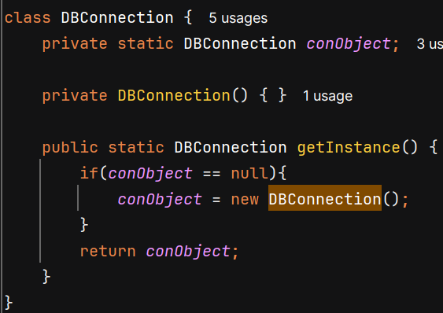

**Synchronized Method –**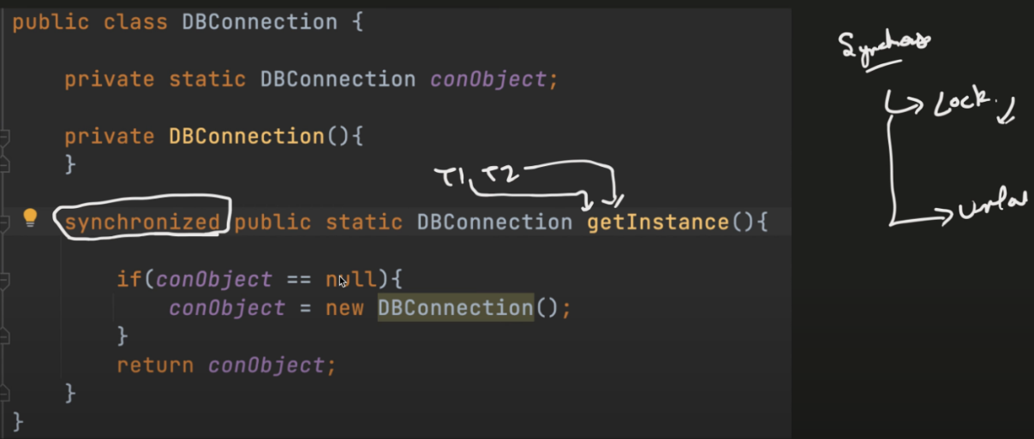

Problem: when you declare the entire method as synchronized, every call to getInstance() requires acquiring a lock, even after the instance has already been created.

**Double Locking –**

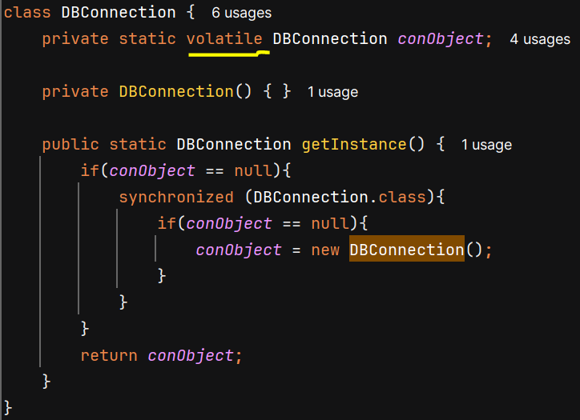

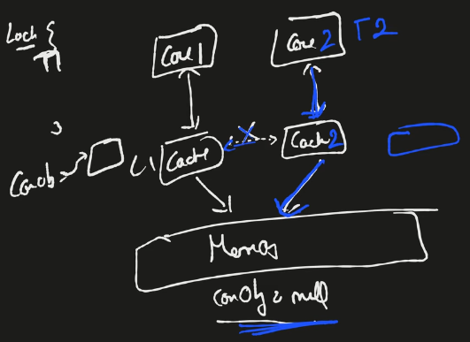

In a CPU, there are multiple core each having its own L1 cache and each CPU core may keep writes in its local cache and periodically update the main memory (RAM)

Suppose both thread1 and thread2 comes parallely. T1 starts running on core1 and T2 starts running on core2. T1 updates value of conObject but changes are only its cache, and sync up between core1 and core2 caches has not happened yet. Now T2 processing in core2 will see that conObject is still null so it will also create a new object. So, due to cache 2 objects are created and singleton class is not achieved.

**Bill Pugh Solution –**

It put initialization part in nested class as nested (static inner) class is not loaded / *initialized* when the outer class is loaded. JVM loads the inner class only when it is actively used.

JVM uses monitor lock to ensue that class initialization is thread-safe and gaurantees that a class’s static initialization is executed only once by a single thread.

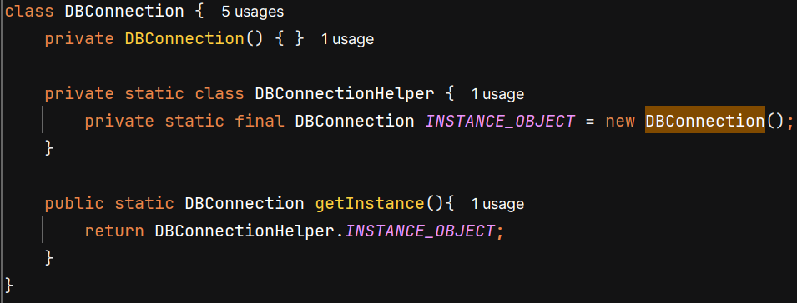

**ENUM –**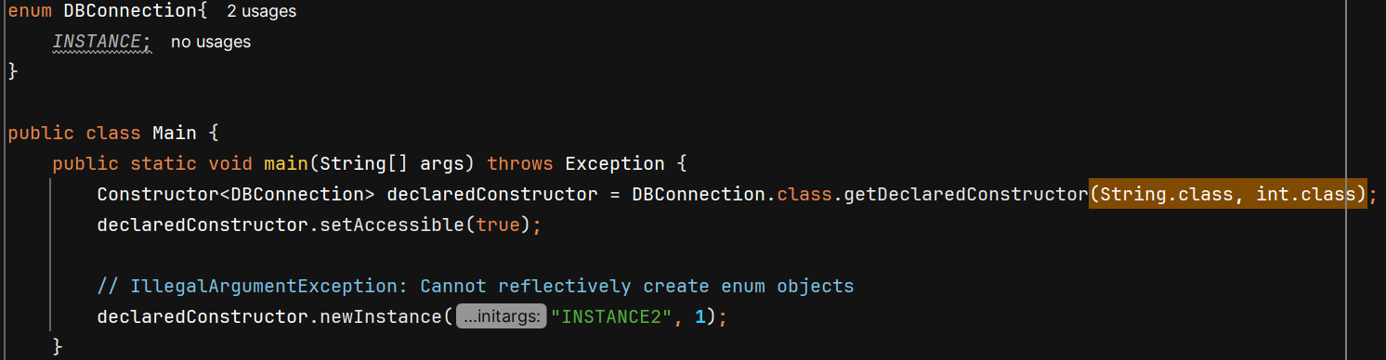

Enum guarantees that there will be only one instance for each defined constant, and you cannot create more instances of DBConnection because Enum don’t allow external instantiation.

Enum Singleton is safe from Reflection (get exception on newInstance()), Serialization (same instance is returned) and Cloning (cannot be cloned)

**Different ways to break Singleton and their solution**

**1. Using Reflection –**

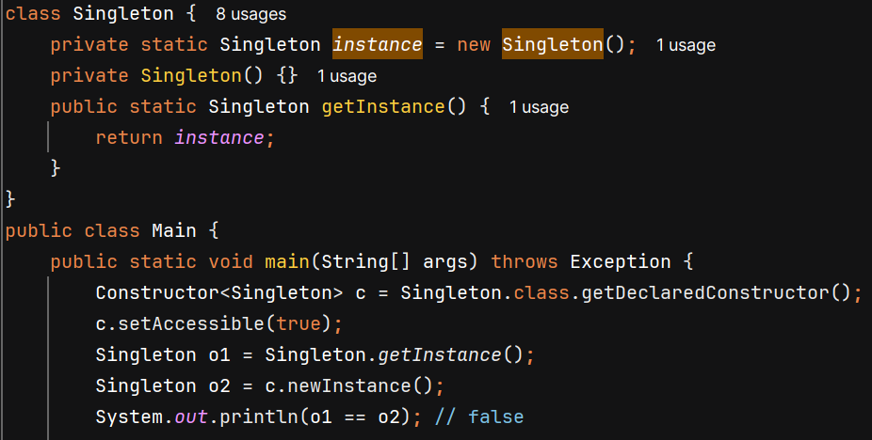

**Solution –** 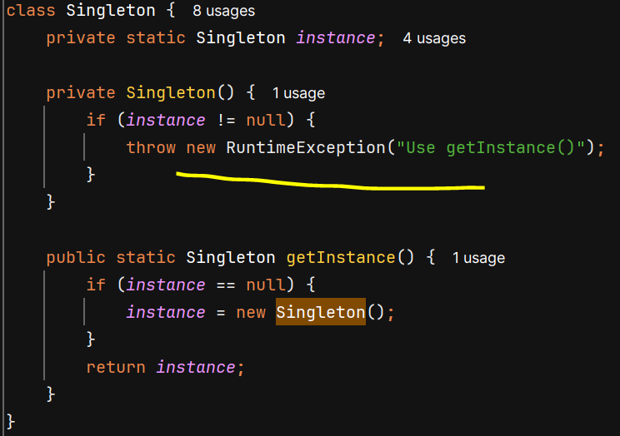

**2. Using Serialization –**

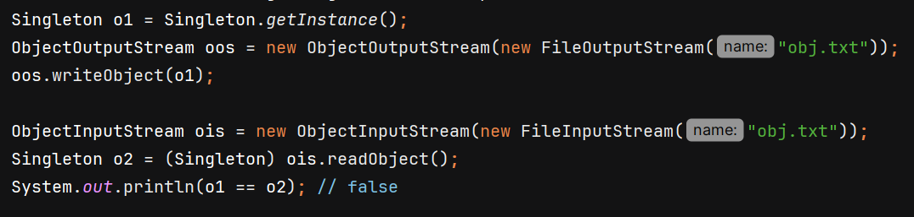

**Solution –**

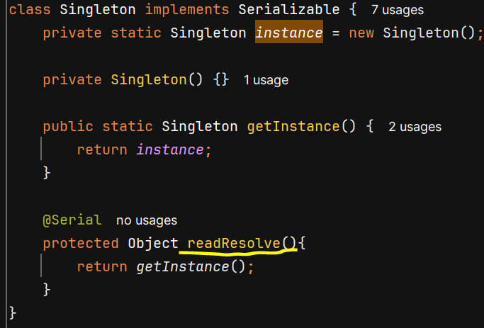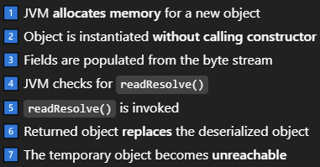

**3. Using Clone –**

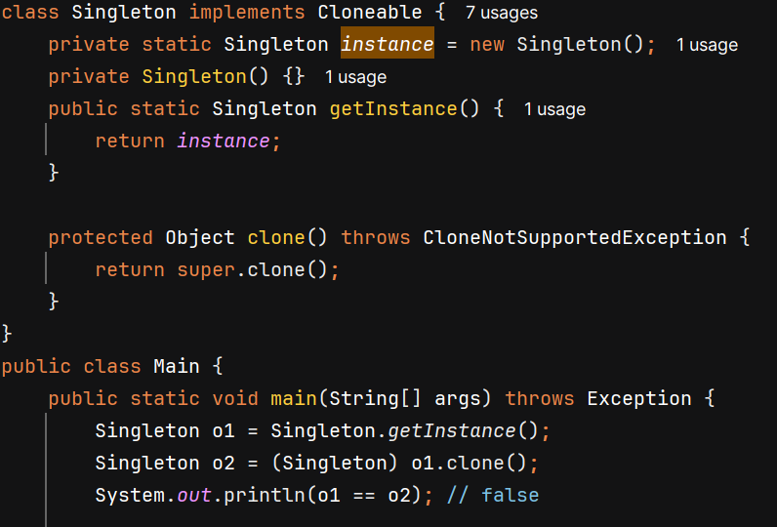

**Solution –** 